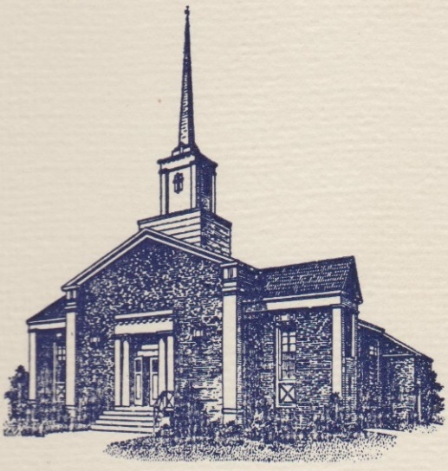
Sunset Hills United
Presbyterian Church
900 Country Club Drive
Pittsburgh, PA 15228
www.shupchurch.org
10:15 am WORSHIP
August 23, 2026
13th Sunday After Pentecost

IN PREPARATION FOR WORSHIP

“But the midwives feared God; they did not do as the king of Egypt commanded them, but they let the boys live.”
– Exodus 1:17, NRSVUE

“Our problems stem from our acceptance of this filthy, rotten system.”
– Dorothy Day, Roman Catholic Activist

ENTERING GOD’S PRESENCE

Prelude

Announcements

Lighting of the Christ Candle

Prayer of Preparation

Introit: Sweet, Sweet Spirit B & G Gaither

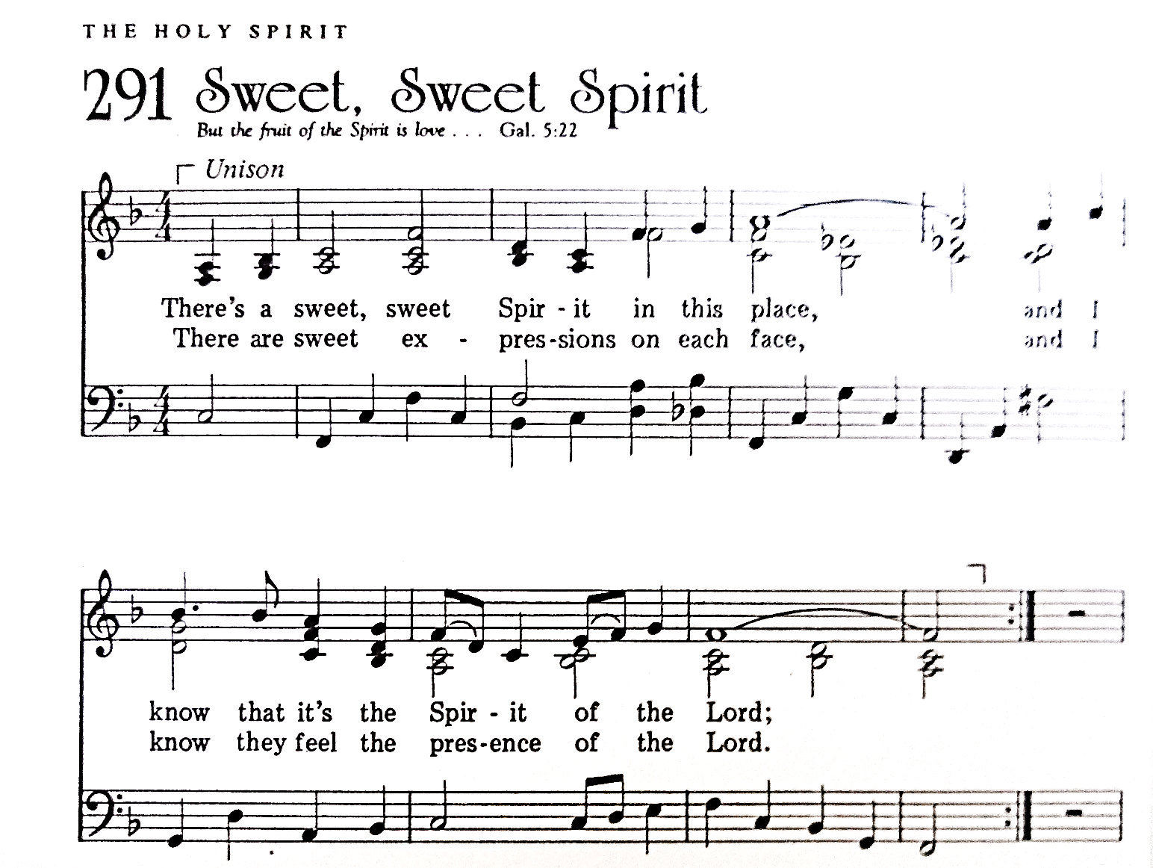
CCLI #1065469

Call to Worship: Liturgist: Bev Knasko

Leader: God is present— not always in the loud or obvious—
People: but in what is small, faithful, and persistent.
Leader: Come, let us worship.
People: We worship with joy, with hope, and with hearts wide open to God.

Hymn: Somebody’s Knockin’ at Your Door No. 382

*Call to Confession:
There are moments that ask something of us— not loudly, not dramatically, but quietly. A chance to speak, or to listen. To act, or to look away. We don’t always notice those moments. And when we do, we don’t always choose well. Still, God meets us there— not with condemnation, but with mercy. So let us come before God, honest about who we are, and open to who we are becoming. Let us pray.

*Prayer of Confession:
God of justice and mercy, we confess that we do not always remember. We forget the stories of suffering. We forget the people pushed to the margins. We forget how easily fear can turn into harm. Like Pharaoh, we are tempted to protect what we have at the expense of others. We confess, too, that we underestimate the power of small acts— quiet courage, hidden resistance, everyday faithfulness. Forgive us. Open our eyes to injustice. Strengthen our courage. Teach us to act with compassion and conviction. Help us to trust that even when we feel small,
you are working through us for good. We ask this in Jesus’ name. Amen.

*Assurance of Pardon:
Leader: Friends, hear the good news: In times of fear and oppression, God does not abandon the world. God works through those who choose life, through those who refuse to harm, through those who protect the vulnerable. That same grace is at work in us. In Jesus Christ, we are forgiven, restored, and called to new life. Thanks be to God.

People: Thanks be to God! We are forgiven. Amen!

*Response Gloria Patri
Glory be to the Father, and to the Son and to the Holy Ghost.
As it was in the beginning, is now and ever shall be.
World without end. Amen. Amen.

*The Passing of the Peace
Leader: Peace be with you.
People: And also with you.

Duet: He Richards & Mullan
(Becky & Harriet Rickard, with Dave Petty & Keith Yanda)

HEARING GOD’S WORD

Hymn: Jesus Loves Me!

Children’s Story Time

Scripture Readings:

Old Testament: Exodus 1:8-2:10

The Israelites Are Oppressed
⁸ Now a new king arose over Egypt, who did not know Joseph. ⁹ He said to his people, ‘Look, the Israelite people are more numerous and more powerful than we. ¹⁰ Come, let us deal shrewdly with them, or they will increase and, in the event of war, join our enemies and fight against us and escape from the land.’ ¹¹ Therefore they set taskmasters over them to oppress them with forced labour. They built supply cities, Pithom and Rameses, for Pharaoh. ¹² But the more they were oppressed, the more they multiplied and spread, so that the Egyptians came to dread the Israelites. ¹³ The Egyptians became ruthless in imposing tasks on the Israelites, ¹⁴ and made their lives bitter with hard service in mortar and brick and in every kind of field labour. They were ruthless in all the tasks that they imposed on them.
¹⁵ The king of Egypt said to the Hebrew midwives, one of whom was named Shiphrah and the other Puah, ¹⁶ ‘When you act as midwives to the Hebrew women, and see them on the birthstool, if it is a boy, kill him; but if it is a girl, she shall live.’ ¹⁷ But the midwives feared God; they did not do as the king of Egypt commanded them, but they let the boys live. ¹⁸ So the king of Egypt summoned the midwives and said to them, ‘Why have you done this, and allowed the boys to live?’ ¹⁹ The midwives said to Pharaoh, ‘Because the Hebrew women are not like the Egyptian women; for they are vigorous and give birth before the midwife comes to them.’ ²⁰ So God dealt well with the midwives; and the people multiplied and became very strong. ²¹ And because the midwives feared God, he gave them families. ²² Then Pharaoh commanded all his people, ‘Every boy that is born to the Hebrews^{[a]} you shall throw into the Nile, but you shall let every girl live.’

Birth and Youth of Moses
2 Now a man from the house of Levi went and married a Levite woman. ² The woman conceived and bore a son; and when she saw that he was a fine baby, she hid him for three months. ³ When she could hide him no longer she got a papyrus basket for him, and plastered it with bitumen and pitch; she put the child in it and placed it among the reeds on the bank of the river. ⁴ His sister stood at a distance, to see what would happen to him.
⁵ The daughter of Pharaoh came down to bathe at the river, while her attendants walked beside the river. She saw the basket among the reeds and sent her maid to bring it. ⁶ When she opened it, she saw the child. He was crying, and she took pity on him. ‘This must be one of the Hebrews’ children,’ she said. ⁷ Then his sister said to Pharaoh’s daughter, ‘Shall I go and get you a nurse from the Hebrew women to nurse the child for you?’ ⁸ Pharaoh’s daughter said to her, ‘Yes.’ So the girl went and called the child’s mother. ⁹ Pharaoh’s daughter said to her, ‘Take this child and nurse it for me, and I will give you your wages.’ So the woman took the child and nursed it. ¹⁰ When the child grew up, she brought him to Pharaoh’s daughter, and she took him as her son. She named him Moses,^{[b]} ‘because’, she said, ‘I drew him out^{[c]} of the water.’

New Testament: Romans 12:1-8
The New Life in Christ
12 I appeal to you therefore, brothers and sisters,^{[a]} by the mercies of God, to present your bodies as a living sacrifice, holy and acceptable to God, which is your spiritual^{[b]} worship. ² Do not be conformed to this world,^{[c]} but be transformed by the renewing of your minds, so that you may discern what is the will of God—what is good and acceptable and perfect.^{[d]}
³ For by the grace given to me I say to everyone among you not to think of yourself more highly than you ought to think, but to think with sober judgement, each according to the measure of faith that God has assigned. ⁴ For as in one body we have many members, and not all the members have the same function, ⁵ so we, who are many, are one body in Christ, and individually we are members one of another. ⁶ We have gifts that differ according to the grace given to us: prophecy, in proportion to faith; ⁷ ministry, in ministering; the teacher, in teaching; ⁸ the exhorter, in exhortation; the giver, in generosity; the leader, in diligence; the compassionate, in cheerfulness.

Leader: The Word of the Lord!
People: Thanks be to God.

Sermon Smashing the Pharaoh-archy Rev. Laura Strauss

Hymn: God Bless Your Church with Strength (Tune: This Is My Father’s World) No. 418

RESPONDING TO GOD’S WORD

Affirmation of Faith: adapted from The Scots Confession, 1560
We confess and acknowledge one God alone, to whom alone we must cleave, whom alone we must serve, whom alone we must worship, and in whom alone we put our trust. This God is eternal, infinite, immeasurable, invisible, almighty, and present with us. To this God we belong, and from this God we receive life and breath and all that we have. And so we trust God— in all times, in all places, and in all things. Amen.
Joys, Concerns, & Testimonies

Prayers of the People & The Lord’s Prayer
Our Father who art in heaven, hallowed be thy name.
Thy kingdom come, thy will be done, on earth as it is in heaven.
Give us this day our daily bread;
and forgive us our debts, as we forgive our debtors;
and lead us not into temptation, but deliver us from evil.
For thine is the kingdom and the power and the glory, forever. Amen.

Presenting Gifts, Tithes and Offerings

Prayer of Dedication

*Response: Doxology
Praise God, from whom all blessings flow;
Praise Him, all creatures here below;
Praise Him above, ye heav’nly host;
Praise Father, Son, and Holy Ghost. Amen.

DEPARTING TO SERVE

Hymn: Come Sing, O Church, in Joy! No. 430

Benediction:
May the peace of the Lord Christ go with you; wherever he may send you; may he guide you through the wilderness; protect you through the storm; may he bring you home rejoicing; at the wonders he has shown you; may he bring you home rejoicing; once again into our doors.
Response: Spiritual Amen No. 587

*Postlude
*If you are able to do so, please stand

* * * * * * * * * * * * * * * * * * * * *

Many thanks to Becky & Harriet Rickard (with Dave Petty & Keith Yanda) for their special music this morning!

Chancel Flowers were given by the Fako family in memory of their parents and grandparents.

Happy Birthday to: Chip McCoy (08/25), Kay Walker (08/28), Emily Yates (08/29), Grace Yates (08/30). (Please contact the church office if we have missed your birthday or anniversary.)

Happy Anniversary to: David and Carla Greenfield (08/23), Frank and Lee Cepits (08/24).

Deacon Greeters/Flower Deliveries: Jonathan Fako

Most Needed Items for SHIM: Dried beans, lentils, pasta sauce in jars, cereal & oatmeal, soup, condiments, spices, adult diapers, baby diapers (size 4-6), dog and cat food, and personal care items.

SHIM Clothing Closet: Accepting donations of clothes (in season), shoes, and linens (no large household items). Located at the Church of Nazarene (5601 Library Road). Drop-off hours: Mondays 10:00 am until 1:00 pm. If you are not able to deliver your donations during their hours, you can leave them in the closet outside of Findley Hall and a Mission Commission member will deliver them for you.

Hospital visits by Pastor Laura can be scheduled through the church office. If you or someone you know is having surgery or is in the hospital, please let us know so that Pastor Laura can be there to visit and pray with you and your loved ones.

Scheduling a Meeting with Pastor Laura: If you would like to meet with Pastor Laura to discuss a matter that is not a medical or pastoral care emergency, please reach out to her. You can contact her via email at revlaurastrauss@gmail.com or by calling the church office at (412) 561-6261 to schedule a meeting. Dropping in to say “hi” is always appreciated, but scheduling a meeting ensures that Pastor Laura can dedicate the necessary time to your discussion if needed.

PRAYER LIST
(Please contact the church office if you would like to add or update a prayer request.)

Prayer Circle: Harriet Ross and Matt & Brienne Sembrat.

August: The Family of Mary Cutting, Jan Paulsen, The Van Haitsma family (death of their daughter), Rev. Brenda Barnes (colleague of Pastor Laura; car accident), Tim Fako (prayers for joy in retirement), Myra Mann (Bread for the World Member, Broken Bones from Fall, Recovering at Friendship Village), Lisa Fako (Healthy and peaceful recovery after melanoma surgery).

July: Evelyn Lape (broken foot)

Ongoing – Captain Sam Wright; Ron Sumner; Nancy Brumfield; our mission co-workers at the U.S.-Mexico border, the Rev. Mark Adams and Miriam Maldonado Escobar and their children, Cindy, Anna Flor, and Nathan; our sister church in Malawi, Africa, Litchenza CCAP; our WorldVision child, Pabatso Makhalanyane; and all those who are affected by natural disasters.

ANNOUNCEMENTS

- Welcome Visitors! If you are worshiping here for the first time today, welcome! We are glad to have you with us.

- Offering: The offering is collected following worship by an elder at the back of the sanctuary who will be holding an offering basket. We can also give online by going to shupchurch.org. Our gifts take many forms: open-hearted presence here, voices lifted in song, the prayers that rise in us, the material gifts we share with neighbors, and our willingness to live in a world as allies and advocates for those whose needs are overlooked. The monies we bring symbolize the offering of our lives in all circumstances.

- Adult Sunday School: Let's start at the very beginning! We're studying Genesis using a curriculum by Dr. Amy-Jill Levine. She presents Genesis as a living text, one that continues to shape faith, identity, and our understanding of what it means to be human. This class will attend to this ancient books' beauty, tension, and enduring questions. The study begins on Sunday, August 30 during the 9:00 a.m. Adult Sunday School Class in Findlay Hall. You're invited.

- Ecumenical Community Gathers to Pray Outside ICE Offices Weekly prayer vigils continue every Friday morning at 8:30 a.m. outside the Immigration & Customs Enforcement (ICE) Office in Pittsburgh's South Side (3000 Sidney St, 15203). Facilitated by a different faith community each week, the vigil is a legal, peaceful witness of support for local immigrants. People of all faith backgrounds are welcome and Presbyterians are always represented well.

- Read the New Testament in ’26: A Bible reading and discussion group is taking place at 6:30 pm, at the home of Jeff Alllison. Call or text Jeff at 412-780-3787 for details and sign-ups.

- Book Club: The August meeting will be held August 26 and we will be discussing Aziz Abu Sarah and Maoz Inon’s nonfiction memoir, The Future Is Peace.

- Refugee Youth in need! Do you have space in your heart and home for a Refugee Youth in need? Bethany Christian Services’ Refugee Foster Care Program is currently looking for foster homes for Refugee Youth between the ages of 12-17. The children in the program do not have family reunification possibilities and are in desperate need of long-term, loving placements. The majority of the children are Christian/Catholic youth arriving from Central and South America. The children all have legal status in the United States and a pathway to US Citizenship. If you are interested in learning more, please contact Annelise Halstead at annelisehalstead@bethany.org or visit our website at www.bethany.org/refugeefostercare

- Pet Blessing: All species welcome on a leash or in a carrier. There will be Blessings, food, games and fun for the whole family on August 30th from 6-8pm. We look forward to meeting you and your pet!

- Summer SHUP Diaper Drive for SHIM: Every little one deserves dry and clean diapers, but many families cannot afford them. You can help! Donate diapers and wipes for SHIM's service toward local families in need. Size 4, 5, and 6 are most needed, and pull-ups are always helpful. We will be collecting through August 30 and diapers can be dropped off in the Pack N Play in the Narthex. Together, we can keep little ones happy and healthy. Thank you for your generosity!

- Holy Curiosity Sermon Series: The Bible is full of passages that make us laugh, scratch our heads, argue, wonder, and occasionally say, "Wait - that's in there?" This October and November, Pastor Laura's turning to you. What Scripture have you never heard preached but wish you had? What story deserves another chance? What text has puzzled or inspired you? Drop your suggestions in the wicker basket in the Narthex. Pastor Laura will use these suggestions, and they do not need to have a name on them. Together we'll explore some of the Bible's most surprising corners and discover what treasures await us there.

- Faith and the World: Cookie Chats: You're invited to join Pastor Laura in the church library on the second Sunday of the month at 7:00 p.m. for Cookie Chats. Bring your own beverage and cookies will be provided. The schedule is as follows:
September 13: Artificial Intelligence - AI is changing the way we work, learn, and relate. What wisdom does the Christian faith offer in this new era?
October 11: Death and Dying - Most of us avoid talking about death until we can't. Let's explore what the Christian faith has to say about mortality, grief, and hope. From funeral homes to resurrection hope, how does the Christian story help us face death?
November 8: Christian Nationalism - Can love of country and loyalty to Christ ever come into tension? Let's explore the question together. What happens when religious identity and national identity become difficult to distinguish?
January 10: Loneliness and Belonging - We're living through what some researchers call an epidemic of loneliness. What is loneliness doing to us, and what does the church have that social media, streaming services, and busy schedules cannot provide?

- Articles for The Messenger: If you plan on submitting an article for The Messenger, please do so by the 15th of each month.


Welcome to
Sunset Hills
United Presbyterian Church
Phone: 412-561-6261
Office hours: Monday, Tuesday, Thursday, 9:00 am – 2:00 pm
900 Country Club Dr. Pittsburgh, PA 15228
www.shupchurch.org

CHURCH CALENDAR

Sunday, August 23
9:00 am – Adult Sunday School–Findley
9:00 am – Children’s Sunday School
10:15 am – Worship–Sanctuary
10:45 am – Children’s Church–Room 113
2:00 pm – Girl Scouts

Monday, August 24
9:00 am – Monday Morning Marvels

Tuesday, August 25
10:00 am – Staff Meeting
7:00 pm – Square Dance Club – Crystal
7:00 pm – Counseling Group–Marvel’s Lounge

Wednesday, August 26
10:00 am – Days for Girls
2:00 pm – Parkinson’s Exercise Group
4:00 pm – Quilters
7:30 pm – Book Club
Thursday, August 27
9:30 am – Preschool Readiness

Friday, August 28
5:00 pm – AA

Sunday, August 30
9:00 am – Adult Sunday School–Findley
9:00 am – Children’s Sunday School
10:15 am – Worship – Sanctuary
10:45 am – Children’s Church – Rm 113
2:00 pm – Girl Scouts

