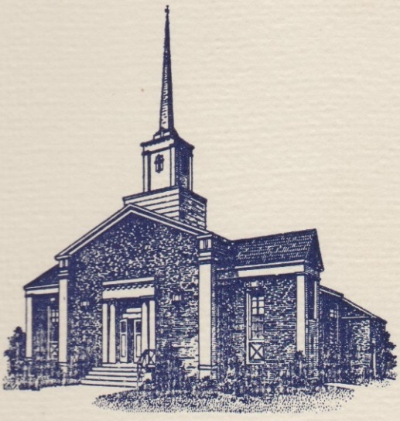
Sunset Hills United
Presbyterian Church
900 Country Club Drive
Pittsburgh, PA 15228
www.shupchurch.org
10:15 am WORSHIP
August 30, 2026
14th Sunday After Pentecost

IN PREPARATION FOR WORSHIP

“Earth’s crammed with heaven, And every common bush afire with God; But only he who sees, takes off his shoes.”
– Elizabeth Barrett Browning, English Poet (1806-1861)

“Do not come any closer," God said, "Take off your sandals, for the place where you are standing is holy ground.”
– Exodus 3:5

ENTERING GOD’S PRESENCE

Prelude

Announcements

Lighting of the Christ Candle

Prayer of Preparation

Introit: Sweet, Sweet Spirit B & G Gaither

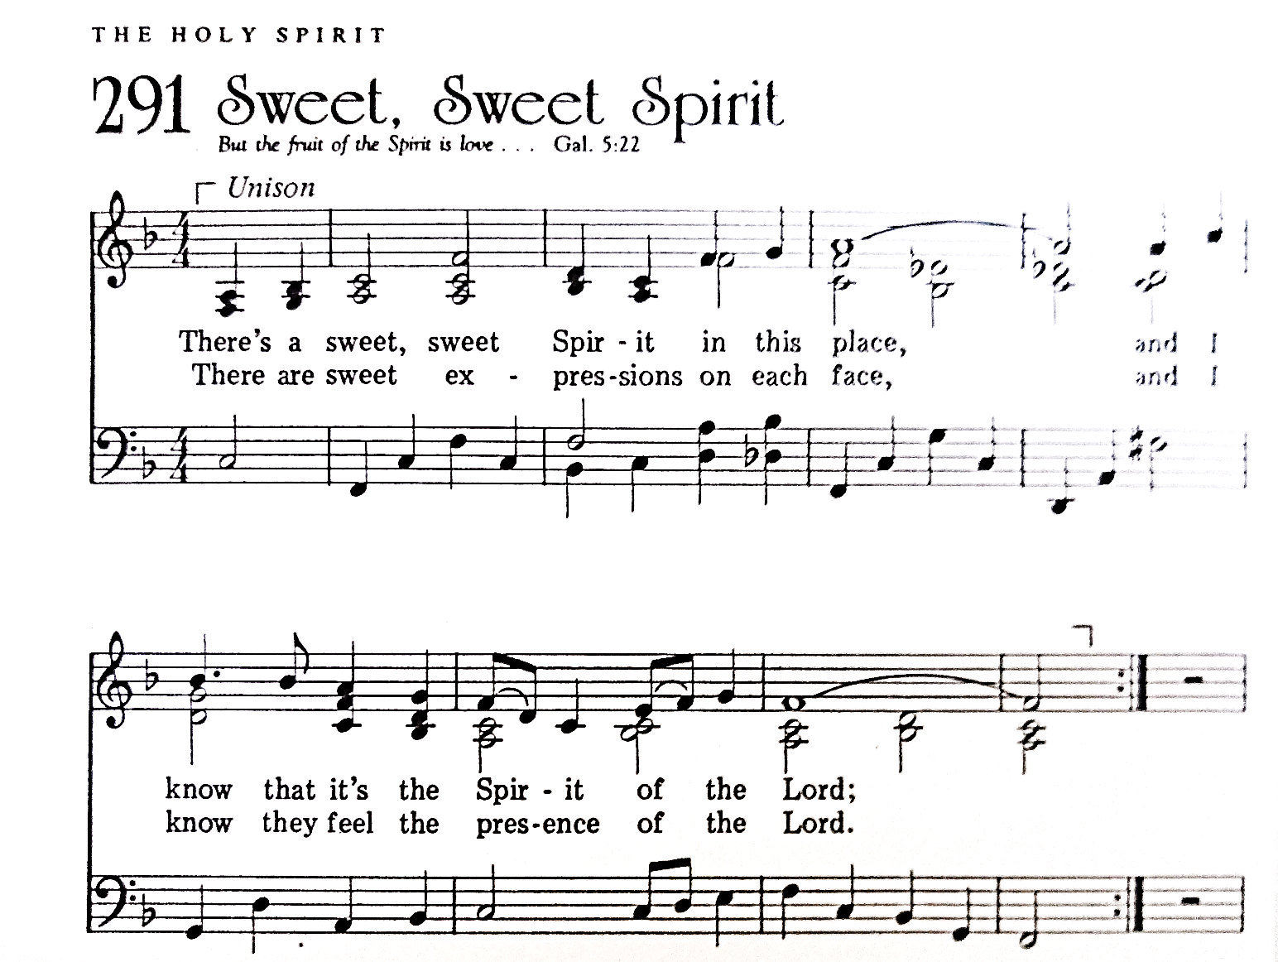
CCLI #1065469

Call to Worship: Liturgist: Tim Fako

Leader: There are moments when something ordinary becomes something more when we pause, and realize we are standing on holy ground.
People: We come, wondering where God might meet us today.
Leader: Not only in sacred spaces, but in the middle of our lives God calls us in conversations, in decisions, in quiet moments we almost miss.
People: We come to listen. We come to notice. We come to worship.

Hymn: O Christ, the Great Foundation No. 443

*Call to Confession:
God calls us by name and invites us into lives shaped by love. We struggle to do this without pretense, to bless instead of curse, to live at peace with one another. So let us come before God— honest, open, and ready to begin again.

*Prayer of Confession:
Holy God, you meet us in places we do not expect— in the middle of our days, in the midst of ordinary life. But we confess how easily we move past you. We are distracted. We are hurried. We are slow to listen. You call us to love sincerely, but we keep our distance. You call us to patience, but we grow frustrated. You call us to live at peace, but we hold on to what divides. Forgive us. Slow us down. Help us to notice where you are already present. Help us to hear when you call our name. Shape in us a love that is genuine, steady, and real. We ask this in Jesus’ name. Amen.

*Assurance of Pardon:
Leader: Hear the good news: God meets us in the middle of things— in our imperfect love, in our unfinished lives, in our attempts to begin again. In Jesus Christ, we are forgiven.

People: Thanks be to God! By the power of the Holy Spirit, we are made whole and sent to share peace with the world. Amen.

*Response Gloria Patri
Glory be to the Father, and to the Son and to the Holy Ghost.
As it was in the beginning, is now and ever shall be.
World without end. Amen. Amen.

*The Passing of the Peace
Leader: Peace be with you.
People: And also with you.

GPM: Turn, Turn, Turm P. Seger
(Frank Cepits, Tim Fako, Ryan Gracey, Dave Petty, Mike Robinson, Keith Yanda)

HEARING GOD’S WORD

Hymn: Jesus Loves Me!

Children’s Story Time

Scripture Readings:

Old Testament: Exodus 3:1-15
3 Moses was keeping the flock of his father-in-law Jethro, the priest of Midian; he led his flock beyond the wilderness, and came to Horeb, the mountain of God. ² There the angel of the Lord appeared to him in a flame of fire out of a bush; he looked, and the bush was blazing, yet it was not consumed. ³ Then Moses said, ‘I must turn aside and look at this great sight, and see why the bush is not burned up.’ ⁴ When the Lord saw that he had turned aside to see, God called to him out of the bush, ‘Moses, Moses!’ And he said, ‘Here I am.’ ⁵ Then he said, ‘Come no closer! Remove the sandals from your feet, for the place on which you are standing is holy ground.’ ⁶ He said further, ‘I am the God of your father, the God of Abraham, the God of Isaac, and the God of Jacob.’ And Moses hid his face, for he was afraid to look at God.
⁷ Then the Lord said, ‘I have observed the misery of my people who are in Egypt; I have heard their cry on account of their taskmasters. Indeed, I know their sufferings, ⁸ and I have come down to deliver them from the Egyptians, and to bring them up out of that land to a good and broad land, a land flowing with milk and honey, to the country of the Canaanites, the Hittites, the Amorites, the Perizzites, the Hivites, and the Jebusites. ⁹ The cry of the Israelites has now come to me; I have also seen how the Egyptians oppress them. ¹⁰ So come, I will send you to Pharaoh to bring my people, the Israelites, out of Egypt.’ ¹¹ But Moses said to God, ‘Who am I that I should go to Pharaoh, and bring the Israelites out of Egypt?’ ¹² He said, ‘I will be with you; and this shall be the sign for you that it is I who sent you: when you have brought the people out of Egypt, you shall worship God on this mountain.’
¹³ But Moses said to God, ‘If I come to the Israelites and say to them, “The God of your ancestors has sent me to you”, and they ask me, “What is his name?” what shall I say to them?’ ¹⁴ God said to Moses, ‘I am who I am.’^{[a]} He said further, ‘Thus you shall say to the Israelites, “I am has sent me to you.”’ ¹⁵ God also said to Moses, ‘Thus you shall say to the Israelites, “The Lord,^{[b]} the God of your ancestors, the God of Abraham, the God of Isaac, and the God of Jacob, has sent me to you”:
This is my name for ever,
and this my title for all generations.

New Testament: Romans 12:9-21
⁹ Let love be genuine; hate what is evil, hold fast to what is good; ¹⁰ love one another with mutual affection; outdo one another in showing honour. ¹¹ Do not lag in zeal, be ardent in spirit, serve the Lord.^{[a]} ¹² Rejoice in hope, be patient in suffering, persevere in prayer. ¹³ Contribute to the needs of the saints; extend hospitality to strangers.
¹⁴ Bless those who persecute you; bless and do not curse them. ¹⁵ Rejoice with those who rejoice, weep with those who weep. ¹⁶ Live in harmony with one another; do not be haughty, but associate with the lowly;^{[b]} do not claim to be wiser than you are. ¹⁷ Do not repay anyone evil for evil, but take thought for what is noble in the sight of all. ¹⁸ If it is possible, so far as it depends on you, live peaceably with all. ¹⁹ Beloved, never avenge yourselves, but leave room for the wrath of God;^{[c]} for it is written, ‘Vengeance is mine, I will repay, says the Lord.’ ²⁰ No, ‘if your enemies are hungry, feed them; if they are thirsty, give them something to drink; for by doing this you will heap burning coals on their heads.’ ²¹ Do not be overcome by evil, but overcome evil with good.

Leader: The Word of the Lord!
People: Thanks be to God.

Sermon Why’d You Come in Here Lookin’ Like That? Rev. Laura Strauss

Hymn: Though I May Speak No. 335

RESPONDING TO GOD’S WORD

Affirmation of Faith: The Scots Confess, 1560, Chapter One
We confess and acknowledge one God alone, to whom alone we must cleave, whom alone we must serve, whom alone we must worship, and in whom alone we put our trust; who is eternal, infinite, immeasurable, incomprehensible, omnipotent, invisible; one in substance and yet distinct in three persons. By whom we confess and believe all things in heaven and earth, visible and invisible, to have been created, to be retained in their being, and to be ruled and guided by God’s inscrutable providence for such end as God’s eternal wisdom, goodness, and justice have appointed, and to the manifestation of God’s own glory.

Joys, Concerns, & Testimonies

Prayers of the People & The Lord’s Prayer
Our Father who art in heaven, hallowed be thy name.
Thy kingdom come, thy will be done, on earth as it is in heaven.
Give us this day our daily bread;
and forgive us our debts, as we forgive our debtors;
and lead us not into temptation, but deliver us from evil.
For thine is the kingdom and the power and the glory, forever. Amen.

Presenting Gifts, Tithes and Offerings

Prayer of Dedication

*Response: Doxology
Praise God, from whom all blessings flow;
Praise Him, all creatures here below;
Praise Him above, ye heav’nly host;
Praise Father, Son, and Holy Ghost. Amen.

DEPARTING TO SERVE

Hymn: Help Us Accept Each Other (Tune: Stand Up for Jesus) No. 358

Benediction:
May the peace of the Lord Christ go with you; wherever he may send you; may he guide you through the wilderness; protect you through the storm; may he bring you home rejoicing; at the wonders he has shown you; may he bring you home rejoicing; once again into our doors.
Response: Spiritual Amen No. 587

*Postlude
*If you are able to do so, please stand

* * * * * * * * * * * * * * * * * * * * *

Many thanks to GPM (Frank, Tim, Ryan, Dave, Mike & Keith) for their special music this morning!

Chancel Flowers were given by Kay Walker in memory of their parents and sister.

Happy Birthday to: Grace Yates (08/30), Betty Coffey (08/31), Ryan Dawson (09/01), Declan Hoffman (09/01), Lisa Ursitz (09/01), Jeff Allison (09/05), Andrew Gracey (09/05), Meg MacDougall (09/05). (Please contact the church office if we have missed your birthday or anniversary.)

Happy Anniversary to: Ian and Jenny Ney (09/01), Ray and Ginny Bowman (09/02), Garth and Amanda Zeglin (09/05).

Deacon Greeters/Flower Deliveries: Mike Duffner

Most Needed Items for SHIM: Dried beans, lentils, pasta sauce in jars, cereal & oatmeal, soup, condiments, spices, adult diapers, baby diapers (size 4-6), dog and cat food, and personal care items.

SHIM Clothing Closet: Accepting donations of clothes (in season), shoes, and linens (no large household items). Located at the Church of Nazarene (5601 Library Road). Drop-off hours: Mondays 10:00 am until 1:00 pm. If you are not able to deliver your donations during their hours, you can leave them in the closet outside of Findley Hall and a Mission Commission member will deliver them for you.

Hospital visits by Pastor Laura can be scheduled through the church office. If you or someone you know is having surgery or is in the hospital, please let us know so that Pastor Laura can be there to visit and pray with you and your loved ones.

Scheduling a Meeting with Pastor Laura: If you would like to meet with Pastor Laura to discuss a matter that is not a medical or pastoral care emergency, please reach out to her. You can contact her via email at revlaurastrauss@gmail.com or by calling the church office at (412) 561-6261 to schedule a meeting. Dropping in to say “hi” is always appreciated, but scheduling a meeting ensures that Pastor Laura can dedicate the necessary time to your discussion if needed.

PRAYER LIST
(Please contact the church office if you would like to add or update a prayer request.)

Prayer Circle: Thomas & Judy Stacey and Jeannine Stimmel.

August: The Family of Mary Cutting, Jan Paulsen, The Van Haitsma family (death of their daughter), Rev. Brenda Barnes (colleague of Pastor Laura; car accident), Tim Fako (prayers for joy in retirement), Myra Mann (Bread for the World Member, Broken Bones from Fall, Recovering at Friendship Village), Lisa Fako (Healthy and peaceful recovery after melanoma surgery).

July: Evelyn Lape (broken foot)

Ongoing – Captain Sam Wright; Ron Sumner; Nancy Brumfield; our mission co-workers at the U.S.-Mexico border, the Rev. Mark Adams and Miriam Maldonado Escobar and their children, Cindy, Anna Flor, and Nathan; our sister church in Malawi, Africa, Litchenza CCAP; our WorldVision child, Pabatso Makhalanyane; and all those who are affected by natural disasters.

ANNOUNCEMENTS

- Welcome Visitors! If you are worshiping here for the first time today, welcome! We are glad to have you with us.

- Offering: The offering is collected following worship by an elder at the back of the sanctuary who will be holding an offering basket. We can also give online by going to shupchurch.org. Our gifts take many forms: open-hearted presence here, voices lifted in song, the prayers that rise in us, the material gifts we share with neighbors, and our willingness to live in a world as allies and advocates for those whose needs are overlooked. The monies we bring symbolize the offering of our lives in all circumstances.

- Adult Sunday School: Let's start at the very beginning! We're studying Genesis using a curriculum by Dr. Amy-Jill Levine. She presents Genesis as a living text, one that continues to shape faith, identity, and our understanding of what it means to be human. This class will attend to this ancient books' beauty, tension, and enduring questions. The study begins on Sunday, August 30 during the 9:00 a.m. Adult Sunday School Class in Findlay Hall. You're invited.

- Ecumenical Community Gathers to Pray Outside ICE Offices Weekly prayer vigils continue every Friday morning at 8:30 a.m. outside the Immigration & Customs Enforcement (ICE) Office in Pittsburgh's South Side (3000 Sidney St, 15203). Facilitated by a different faith community each week, the vigil is a legal, peaceful witness of support for local immigrants. People of all faith backgrounds are welcome and Presbyterians are always represented well.

- Read the New Testament in ’26: A Bible reading and discussion group is taking place at 6:30 pm, at the home of Jeff Alllison. Call or text Jeff at 412-780-3787 for details and sign-ups.

- Book Club: The September meeting will be held September 30th and we will be discussing The Lion Women of Tehran: A Novel by Marjan Kamali.

- Choir & Handbell Choir Return: Choir and Handbell Choir are starting back up! Join us on Tuesday, September 8 as we begin another season of music and fellowship. Handbell Choir meets at 6:30 PM, followed by Choir at 7:30 PM.

- Refugee Youth in need! Do you have space in your heart and home for a Refugee Youth in need? Bethany Christian Services’ Refugee Foster Care Program is currently looking for foster homes for Refugee Youth between the ages of 12-17. The children in the program do not have family reunification possibilities and are in desperate need of long-term, loving placements. The majority of the children are Christian/Catholic youth arriving from Central and South America. The children all have legal status in the United States and a pathway to US Citizenship. If you are interested in learning more, please contact Annelise Halstead at annelisehalstead@bethany.org or visit our website at www.bethany.org/refugeefostercare

- Pet Blessing: All species welcome on a leash or in a carrier. There will be Blessings, food, games and fun for the whole family on August 30th from 6-8pm. We look forward to meeting you and your pet!

- Summer SHUP Diaper Drive for SHIM: Every little one deserves dry and clean diapers, but many families cannot afford them. You can help! Donate diapers and wipes for SHIM's service toward local families in need. Size 4, 5, and 6 are most needed, and pull-ups are always helpful. We will be collecting through August 30 and diapers can be dropped off in the Pack N Play in the Narthex. Together, we can keep little ones happy and healthy. Thank you for your generosity!

- Holy Curiosity Sermon Series: The Bible is full of passages that make us laugh, scratch our heads, argue, wonder, and occasionally say, "Wait - that's in there?" This October and November, Pastor Laura's turning to you. What Scripture have you never heard preached but wish you had? What story deserves another chance? What text has puzzled or inspired you? Drop your suggestions in the wicker basket in the Narthex. Pastor Laura will use these suggestions, and they do not need to have a name on them. Together we'll explore some of the Bible's most surprising corners and discover what treasures await us there.

- Faith and the World: Cookie Chats: You're invited to join Pastor Laura in the church library on the second Sunday of the month at 7:00 p.m. for Cookie Chats. Bring your own beverage and cookies will be provided. The schedule is as follows:
September 13: Artificial Intelligence - AI is changing the way we work, learn, and relate. What wisdom does the Christian faith offer in this new era?
October 11: Death and Dying - Most of us avoid talking about death until we can't. Let's explore what the Christian faith has to say about mortality, grief, and hope. From funeral homes to resurrection hope, how does the Christian story help us face death?
November 8: Christian Nationalism - Can love of country and loyalty to Christ ever come into tension? Let's explore the question together. What happens when religious identity and national identity become difficult to distinguish?
January 10: Loneliness and Belonging - We're living through what some researchers call an epidemic of loneliness. What is loneliness doing to us, and what does the church have that social media, streaming services, and busy schedules cannot provide?

- Articles for The Messenger: If you plan on submitting an article for The Messenger, please do so by the 15th of each month.


Welcome to
Sunset Hills
United Presbyterian Church
Phone: 412-561-6261
Office hours: Monday, Tuesday, Thursday, 9:00 am – 2:00 pm
900 Country Club Dr. Pittsburgh, PA 15228
www.shupchurch.org

CHURCH CALENDAR

Sunday, August 30
9:00 am – Adult Sunday School–Findley
9:00 am – Children’s Sunday School
10:15 am – Worship–Sanctuary
10:45 am – Children’s Church–Room 113
2:00 pm – Girl Scouts

Monday, August 31
9:00 am – Monday Morning Marvels

Tuesday, September 1
7:00 pm – Square Dance Club – Crystal
7:00 pm – Counseling Group–Marvel’s Lounge

Wednesday, September 2
10:00 am – Days for Girls
2:00 pm – Parkinson’s Exercise Group
4:00 pm – Quilters

Thursday, September 3
10:00 am – Nursery School Teacher’s Meeting
6:15 pm – Fall Yoga

Friday, September 4
5:00 pm – AA

Sunday, September 6
9:00 am – Adult Sunday School–Findley
9:00 am – Children’s Sunday School
10:15 am – Worship – Sanctuary
10:45 am – Children’s Church – Rm 113
11:15 am – Fellowship Hour
2:00 pm – Girl Scouts

