
Sunset Hills United
Presbyterian Church
900 Country Club Drive
Pittsburgh, PA 15228
www.shupchurch.org
10:15 am WORSHIP
October 18, 2026
21St Sunday After Pentecost

IN PREPARATION FOR WORSHIP

“If one believes in God one can say anything to God. One can be angry at God, one can praise God, one can demand things of God.”
– Elie Wiesel, Holocaust Survivor and Nobel Peace Prize Laureate

“Rouse yourself! Why do you sleep, O Lord? Awake, do not cast us off forever! Why do you hide your face? Why do you forget our affliction and oppression? We are brought down to the dust; our bodies cling to the ground. Rise up and help us; redeem us because of your unfailing love.”
– Psalm 44:23-26

ENTERING GOD’S PRESENCE

Announcements

Lighting of the Christ Candle

Prayer of Preparation

Introit: Surely the Presence of the Lord L. Wolfe
Surely the presence of the Lord is in this place.
I can feel His mighty power and His grace.
I can hear the brush of angels’ wings,
I see glory on each face.
Surely the presence of the Lord is in this place.
CCLI #1065469

Call to Worship: Liturgist: Harriett Rickard

One: How long, O Lord?
All: We come with questions that have no easy answers.
One: Out of the depths we cry to you.
All: We come with prayers we have carried for days, months, and years.
One: Jesus himself prayed in anguish.
All: We come trusting that doubt and disappointment do not keep us from God.
One: Bring your gratitude. Bring your longing. Bring even the prayers you have stopped praying.
All: We bring our whole selves before God.

Hymn: Morning Has Broken No. 469

*Call to Confession:
Sometimes our disappointment with God becomes anger. Sometimes our fear becomes silence. Sometimes we stop expecting anything at all. And sometimes, when other people suffer, we offer easy answers because their pain makes us uncomfortable. God does not require us to pretend. Trusting that divine mercy is large enough for our truth, let us confess together.

*Prayer of Confession:
Listening God, we confess that prayer confuses us. We have asked and not received. We have sought and not found. We have knocked until our hands were tired and wondered if anyone was on the other side. Forgive us when disappointment hardens into indifference. Forgive us, too, when we explain another person's suffering instead of entering it; when we offer platitudes instead of presence; when we speak for you when silence would be more faithful. Teach us to pray honestly. Teach us to lament without shame. Teach us to hope without pretending. And when we have no words left, hold us in a love deeper than words. Amen.

*Assurance of Pardon:
Leader: Scripture does not promise that faithful people will never question God. It gives us psalms of lament, prophets who protest, disciples who doubt, and Jesus himself crying from the cross. Our questions do not frighten God. Our disappointment does not exile us from grace. Our silence does not separate us from love. Even when we cannot find the words to pray, the Spirit intercedes with sighs too deep for words. In Jesus Christ, we are held, known, and forgiven.

People: Thanks be to God. Amen.

*Response Alleluia!
All creatures, your Creator bless,
And worship God in humbleness.
O sing ye! Alleluia!
Praise, praise the Father, praise the Son,
And praise the Spirit, Three in One!
O sing ye! Alleluia!
Alleluia! Alleluia! Alleluia!
*The Passing of the Peace
Leader: Peace be with you.
People: And also with you.

Anthem: Great Is the Lord M.W. Smith

HEARING GOD’S WORD

Hymn: Jesus Loves Me!

Children’s Story Time

Scripture Readings:

New Testament: 2 Corinthians 12:7-10
⁷ even considering the exceptional character of the revelations. Therefore, to keep^{[a]} me from being too elated, a thorn was given to me in the flesh, a messenger of Satan to torment me, to keep me from being too elated.^{[b]} ⁸ Three times I appealed to the Lord about this, that it would leave me, ⁹ but he said to me, ‘My grace is sufficient for you, for power^{[c]} is made perfect in weakness.’ So, I will boast all the more gladly of my weaknesses, so that the power of Christ may dwell in me. ¹⁰ Therefore I am content with weaknesses, insults, hardships, persecutions, and calamities for the sake of Christ; for whenever I am weak, then I am strong.

Gospel: Matthew 26:36-46
³⁶ Then Jesus went with them to a place called Gethsemane; and he said to his disciples, ‘Sit here while I go over there and pray.’ ³⁷ He took with him Peter and the two sons of Zebedee, and began to be grieved and agitated. ³⁸ Then he said to them, ‘I am deeply grieved, even to death; remain here, and stay awake with me.’ ³⁹ And going a little farther, he threw himself on the ground and prayed, ‘My Father, if it is possible, let this cup pass from me; yet not what I want but what you want.’ ⁴⁰ Then he came to the disciples and found them sleeping; and he said to Peter, ‘So, could you not stay awake with me one hour? ⁴¹ Stay awake and pray that you may not come into the time of trial;^{[a]} the spirit indeed is willing, but the flesh is weak.’ ⁴² Again he went away for the second time and prayed, ‘My Father, if this cannot pass unless I drink it, your will be done.’ ⁴³ Again he came and found them sleeping, for their eyes were heavy. ⁴⁴ So leaving them again, he went away and prayed for the third time, saying the same words. ⁴⁵ Then he came to the disciples and said to them, ‘Are you still sleeping and taking your rest? See, the hour is at hand, and the Son of Man is betrayed into the hands of sinners. ⁴⁶ Get up, let us be going. See, my betrayer is at hand.’

Leader: The Word of the Lord!
People: Thanks be to God.

Sermon What If God Says Nothing? Rev. Dr. Laura Strauss

Hymn: God Will Take Care of You See Insert

RESPONDING TO GOD’S WORD

Affirmation of Faith: The Heidelberg Catechism

One: How does the knowledge of God’s creation and providence help us?
All: We can be patient when things go against us, thankful when things go well, and for the future we can have good confidence in our faithful God and Father that nothing in creation will separate us from his love.

Joys, Concerns, & Testimonies

Prayers of the People & The Lord’s Prayer
Our Father who art in heaven, hallowed be thy name.
Thy kingdom come, thy will be done, on earth as it is in heaven.
Give us this day our daily bread;
and forgive us our debts, as we forgive our debtors;
and lead us not into temptation, but deliver us from evil.
For thine is the kingdom and the power and the glory, forever. Amen.

Presenting Gifts, Tithes and Offerings

Prayer of Dedication

*Response: Doxology
Praise God, from whom all blessings flow;
Praise Him, all creatures here below;
Praise Him above, ye heav’nly host;
Praise Father, Son, and Holy Ghost. Amen.

DEPARTING TO SERVE

Hymn: Our Lord, You Stood in Pilate’s Hall (Tune: O For a Thousand Tongues to Sing) C.W. Gillette

Our Lord, you stood in Pilate’s hall, his judgment to endure.
Yet all he ruled would one day fall; You reign forevermore!

You are our King and yet you said it’s not by sword or might;
Where truth is lived and love is spread, Your reign comes into sight.

Where people live in deep despair, forgotten, hurt, alone,
We hear their urgent, whispered prayer: “When will your reign be known?”

And where your church on earth today is mighty, rich, and strong,
Lord, may we not forget your Way, nor lose your kingdom’s song.

“Thy kingdom come, thy will be done” not just in heaven above;
O God, may we obey your Son, who reigns o’er all in love.
Copyright © 2007 by Carolyn Winfrey Gillette. All rights reserved.

Benediction:
May the peace of the Lord Christ go with you; wherever he may send you; may he guide you through the wilderness; protect you through the storm; may he bring you home rejoicing; at the wonders he has shown you; may he bring you home rejoicing; once again into our doors.
Response: God Be With You
God be with you till we meet again,
loving counsels guide, uphold you,
With a Shepherd’s care enfold you;
God be with you till we meet again.

*Postlude
*If you are able to do so, please stand

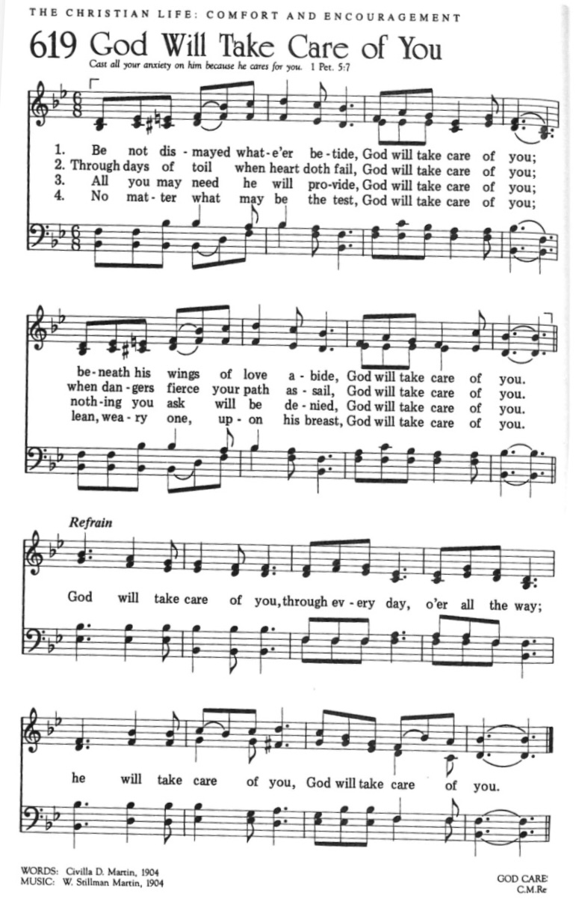

CCLI #1065469

* * * * * * * * * * * * * * * * * * * * *

Chancel Flowers were given by the Rickard Family in memory of Mr. and Mrs. Robert Rickard.

Happy Birthday to: Kara Yates (10/18), Pat Patterson (10/21), Alecia Ney (10/23) (Please contact the church office if we have missed your birthday or anniversary.)

Happy Anniversary to: Paul and Marla Bruschi (10/19), Michael and Kara Frick (10/22).

Deacon Greeters/Flower Deliveries: Harriett Rickard and Leslie Ney.

Most Needed Items for SHIM: Dried beans, lentils, pasta sauce in jars, cereal & oatmeal, soup, condiments, spices, dog and cat food, and personal care items.

SHIM Clothing Closet: Accepting donations of clothes (in season), shoes, and linens (no large household items). Located at the Church of Nazarene (5601 Library Road). Drop-off hours: Mondays 10:00 am until 1:00 pm. If you are not able to deliver your donations during their hours, you can leave them in the closet outside of Findley Hall and a Mission Commission member will deliver them for you.

Hospital visits by Pastor Laura can be scheduled through the church office. If you or someone you know is having surgery or is in the hospital, please let us know so that Pastor Laura can be there to visit and pray with you and your loved ones.

Scheduling a Meeting with Pastor Laura: If you would like to meet with Pastor Laura to discuss a matter that is not a medical or pastoral care emergency, please reach out to her. You can contact her via email at revlaurastrauss@gmail.com or by calling the church office at (412) 561-6261 to schedule a meeting. Dropping in to say “hi” is always appreciated, but scheduling a meeting ensures that Pastor Laura can dedicate the necessary time to your discussion if needed.

PRAYER LIST
(Please contact the church office if you would like to add or update a prayer request.)

Prayer Circle: Alex Tallarico, Julia Tallarico, Lucy Tallarico

October: Joe Barton (seizures), Pope Leo (Lung Cancer), Christopher Ropar (Mary Abbott's brother), Dottie Fleming (Illness), The Family of Bernie Gordon, Family of Conrad Sikirica (Cousin of the Obarsky Family), The Stilley Family (student of Ryan Gracey; sudden passing of mom, April; prayers for husband, Jamie, and kids, Alice and Mallory, and nephew/nieces, Nolan, Mae, and Louis), Becker Family (The passing of John Becker, husband and father) Bayles Family, Mental Health Struggles (Mary Abbott), The Family of Dr. Idris Evans (Died in Home Invasion), Evelyn Lape (On-going Home Repair), Mary Thompson (Dottie Fleming's Sister; Surgery), Family of Barry Luokkala (Friend of Jeff Hinkelman), National Hispanic Heritage Month (Lee Cepits; Prayers of Appreciation)

September: Dorene Hirshika (passing of mom; friend of Darlene Farabaugh), Alecia and Dave Marney (celebration of marriage, Sept. 12, 2026), Linda (car accident, friend of LoAnn Burian), Tom (friend of Rosalie Pillitteri), The Rabbani Family (Granddaughter born with heart problems. Neighbors of the Fako Family.), Evelyn Lape (Damage to her home from the recent storm.), The Brady Family (Damage to their home from the recent storm, Carol Noonan’s neighbor), Lucy Josephine Escobar (new grandchild of Keith and Wendy Yanda, daughter of Michelle (Yanda) and Daniel Escobar), born August 28 in Santa Cruz, CA.

Ongoing – Captain Sam Wright; Ron Sumner; Nancy Brumfield; our mission co-workers at the U.S.-Mexico border, the Rev. Mark Adams and Miriam Maldonado Escobar and their children, Cindy, Anna Flor, and Nathan; our sister church in Malawi, Africa, Litchenza CCAP; our WorldVision child, Pabatso Makhalanyane; and all those who are affected by natural disasters.

ANNOUNCEMENTS

- Welcome Visitors! If you are worshiping here for the first time today, welcome! We are glad to have you with us.

- Offering: The offering is collected following worship by an elder at the back of the sanctuary who will be holding an offering basket. We can also give online by going to shupchurch.org. Our gifts take many forms: open-hearted presence here, voices lifted in song, the prayers that rise in us, the material gifts we share with neighbors, and our willingness to live in a world as allies and advocates for those whose needs are overlooked. The monies we bring symbolize the offering of our lives in all circumstances.

- Pasta for a Purpose: On behalf of the Sunset Hills neighborhood, Please join us for our Pasta for a Purpose Dinner on October 25th at 5:00 pm as we come together to support the Becker family during this difficult time. Your support, generosity, and prayers mean so much to this family as they navigate this season of loss. We hope you’ll join us for a wonderful evening of good food, fellowship, and community support!

- SHUP Flu & COVID Shot Clinic: SHUP’s annual Flu & COVID Shot Clinic will be held on Sunday, October 25, immediately following worship. Immunizations offered will include Flu, Flu HD, COVID, Pneumonia, RSV, and Shingles. If you receive your first Shingles shot at the clinic, you will need to follow up with Pathways for your second dose. Please take advantage of this convenient opportunity to stay up to date on your vaccinations!

- Reformation Sunday: Heritage Item and Wear Plaid Everyone is invited to wear plaid and bring an item that represents their heritage on Sunday, October 25. Items will be placed on the communion table during the Blessing of the Kirken, when Pastor Laura blesses the households. The collection will be a visible indicator of the many backgrounds that gather in our church family. Items can then be taken home following worship.

- Fellowship Hour for Reformation Sunday Join us following worship on Sunday, October 25 as we celebrate Reformation Sunday with a special Fellowship Hour in Findlay Hall!

- Trick or Treat at SHUP Church Don't get many Trick or Treaters at your house? Do you like in an apartment or assisted living facility where no one knocks on your door? Join your church family on Saturday, October 31 to hand out candy on the church steps for Halloween! Pizza will be served at 5:30 p.m. Trick or Treaters will come by from 6:00 - 8:00 p.m. Dress warm and bring enough treats for 125-150 kiddos.

- All Saints' Sunday: November 1 You're invited to join us for a special worship service on Sunday, November 1 as we remember the members of our congregation who have died in the past year. A bell will be rung in their memory, and we will have an opportunity to remember our loved ones who've gone home to the Church Triumphant. The sacrament of communion will be celebrated.

- Hanging of the Greens The Hanging of the Greens will take place following worship on Sunday, November 22. Everyone is invited to stay following worship to prepare the church building for Advent and Christmas.

- Thanksgiving Dinner: You're invited to join Sunset Hills UP Church for Thanksgiving Dinner on Sunday, November 15 at 5:00 p.m. If your name begins with A-L, bring a side dish. If your name begins with M-Z, bring a dessert. Turkey, stuffing and rolls are provided.

- Ecumenical Community Gathers to Pray Outside ICE Offices: Weekly prayer vigils continue every Friday morning at 8:30 a.m. outside the Immigration & Customs Enforcement (ICE) Office in Pittsburgh's South Side (3000 Sidney St, 15203). Facilitated by a different faith community each week, the vigil is a legal, peaceful witness of support for local immigrants. People of all faith backgrounds are welcome and Presbyterians are always represented well.

- Book Club: The September meeting will be held October 28 and we will be discussing A Burning in My Bones: The Authorized Biography of Eugene H. Peterson by Winn Collier.

- Faith and the World: Cookie Chats: You're invited to join Pastor Laura in the church library on the second Sunday of the month at 7:00 p.m. for Cookie Chats. Bring your own beverage and cookies will be provided. The schedule is as follows:
November 8: Christian Nationalism - Can love of country and loyalty to Christ ever come into tension? Let's explore the question together. What happens when religious identity and national identity become difficult to distinguish?
January 10: Loneliness and Belonging - We're living through what some researchers call an epidemic of loneliness. What is loneliness doing to us, and what does the church have that social media, streaming services, and busy schedules cannot provide?

- Articles for The Messenger: If you plan on submitting an article for The Messenger, please do so by the 15th of each month.


Welcome to
Sunset Hills
United Presbyterian Church
Phone: 412-561-6261
Office hours: Monday, Tuesday, Thursday, 9:00 am – 2:00 pm
900 Country Club Dr. Pittsburgh, PA 15228
www.shupchurch.org

CHURCH CALENDAR

Sunday, October 18
9:00 am – Adult Sunday School–Findley
9:00 am – Children’s Sunday School
10:15 am – Worship – Sanctuary
10:45 am – Children’s Church – Rm 113
2:00 pm – Girl Scouts

Monday, October 19
9:00 am – Monday Marvels
1:00 pm – Women’s Bible Study
6:00 pm – Girl Scouts Troop 46920

Tuesday, October 20
12:30 pm – Tuesday Bible Study
6:45 pm – Handbell Choir
7:00 pm – Square Dance Club – Crystal
7:00 pm – Counseling Group–Marvel’s Lounge
7:30 pm – Choir

Wednesday, October 21
10:00 am – Days for Girls
2:00 pm – Parkinson’s Exercise Group
4:00 pm – Quilters
Thursday, October 22
6:15pm – Fall Yoga

Friday, October 23
5:00 pm – AA

Sunday, October 25
9:00 am – Adult Sunday School–Findley
9:00 am – Children’s Sunday School
10:15 am – Worship – Sanctuary
10:45 am – Children’s Church – Rm 113
11:15 am – Flu Clinic
2:00 pm – Girl Scouts
4:00 pm – Girl Scouts Troop 16212
5:00 pm – Pasta for a Purpose

