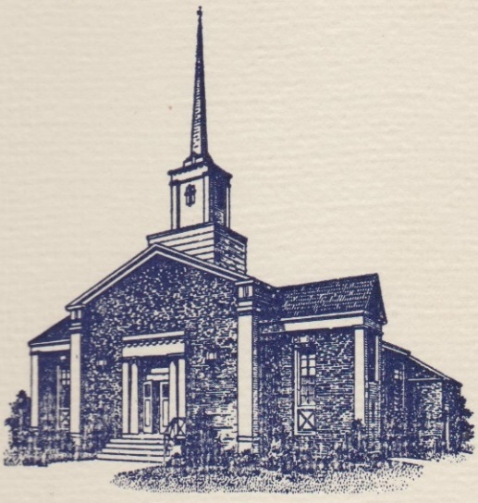
Sunset Hills United
Presbyterian Church
900 Country Club Drive
Pittsburgh, PA 15228
www.shupchurch.org
10:15 am WORSHIP
November 1, 2026
All Saints Sunday

IN PREPARATION FOR WORSHIP

“One short sleep past, we wake eternally, And death shall be no more; Death, thou shalt die.”
– John Donne (1572-1631) - Holy Sonnet X

“Death has been swallowed up in victory. Where, O death, is your victory? Where, O death, is your sting?”
– 1 Corinthians 15:54–55 (NRSVUE)

ENTERING GOD’S PRESENCE

Announcements

Lighting of the Christ Candle

Prayer of Preparation

Introit: Surely the Presence of the Lord L. Wolfe
Surely the presence of the Lord is in this place.
I can feel His mighty power and His grace.
I can hear the brush of angels’ wings,
I see glory on each face.
Surely the presence of the Lord is in this place.
CCLI #1065469

Call to Worship: Liturgist: Linda DeBor

One: See what love God has given us: We are called children of God, and that is what we are.
All: We join our praise with generations before us and generations yet to come.
One: We remember those who have finished their earthly journey.
All: We give thanks for the love they gave, the faith they shared, and the lives they touched. Together with all the saints, let us worship God.

Hymn: For All the Saints No. 526
(See additional note in the announcements section)

*Call to Confession:
God of every generation, we confess that we have not always lived as your beloved children. We forget those who came before us. We inherit courage and choose comfort. We inherit wisdom and refuse to listen. Forgive us. Make us worthy ancestors to those who will come after us. Teach us to love generously, to seek justice courageously, to practice mercy freely, and to leave behind a church and a world more closely resembling your beloved community. Amen.

*Prayer of Confession:
Holy God, we confess that we have not always lived as your saints. We have been timid in our witness, slow to forgive, quick to judge. We have failed to offer grace even as we have depended on yours. Forgive us, O Lord. Remind us of your mercy. Restore us to your service, and strengthen us to walk in the way of Jesus, in whose name we pray. Amen.

*Assurance of Pardon:
Leader: Hear the promise of Scripture: Beloved, we are God's children now. Not when we have perfected ourselves. Not when we have answered every question. Not someday. Now. We belong to the God whose grace is greater than our failures and whose love is stronger than death. In Jesus Christ, we are forgiven.

People: Thanks be to God. Amen.

*Response Gloria Patri
Glory be to the Father, and to the Son and to the Holy Ghost.
As it was in the beginning, is now and ever shall be.
World without end. Amen. Amen.

*The Passing of the Peace
Leader: Peace be with you.
People: And also with you.

Anthem: Come, Dine With Me Baertschi & Schram

HEARING GOD’S WORD

Hymn: Jesus Loves Me!

Children’s Story Time

Scripture Readings:

New Testament: Revelation 7:9-17
9 After this I looked, and there was a great multitude that no one could count, from every nation, from all tribes and peoples and languages, standing before the throne and before the Lamb, robed in white, with palm branches in their hands. 10 They cried out in a loud voice, saying,

‘Salvation belongs to our God who is seated on the throne, and to the Lamb!’

11 And all the angels stood around the throne and around the elders and the four living creatures, and they fell on their faces before the throne and worshipped God, 12 singing,

‘Amen! Blessing and glory and wisdom
and thanksgiving and honour
and power and might
be to our God for ever and ever! Amen.’

13 Then one of the elders addressed me, saying, ‘Who are these, robed in white, and where have they come from?’ 14 I said to him, ‘Sir, you are the one that knows.’ Then he said to me, ‘These are they who have come out of the great ordeal; they have washed their robes and made them white in the blood of the Lamb.

15 For this reason they are before the throne of God,
and worship him day and night within his temple,
and the one who is seated on the throne will shelter them.
16 They will hunger no more, and thirst no more;
the sun will not strike them,
nor any scorching heat;
17 for the Lamb at the centre of the throne will be their shepherd,
and he will guide them to springs of the water of life,
and God will wipe away every tear from their eyes.’

Gospel: Matthew 5:1-12
5 When Jesus saw the crowds, he went up the mountain; and after he sat down, his disciples came to him. 2 Then he began to speak, and taught them, saying:

3 ‘Blessed are the poor in spirit, for theirs is the kingdom of heaven.
4 ‘Blessed are those who mourn, for they will be comforted.
5 ‘Blessed are the meek, for they will inherit the earth.
6 ‘Blessed are those who hunger and thirst for righteousness, for they will be filled.
7 ‘Blessed are the merciful, for they will receive mercy.
8 ‘Blessed are the pure in heart, for they will see God.
9 ‘Blessed are the peacemakers, for they will be called children of God.
10 ‘Blessed are those who are persecuted for righteousness’ sake, for theirs is the kingdom of heaven.
11 ‘Blessed are you when people revile you and persecute you and utter all kinds of evil against you falsely on my account. 12 Rejoice and be glad, for your reward is great in heaven, for in the same way they persecuted the prophets who were before you.

Leader: The Word of the Lord!
People: Thanks be to God.

Sermon All of Us; Each of Us Rev. Dr. Laura Strauss

Hymn: Here, O Our Lord, We See You Face to Face (vs. 1-4) No. 520

Sacrament of Holy Communion
The Invitation
The Great Thanksgiving
Pastor: The Lord be with you.
People: And also with you.
Pastor: Lift up your hearts.
People: We lift them up to the Lord.
Pastor: Let us give thanks to the Lord our God.
People: It is right to give Him thanks and praise.
Pastoral Prayer
Holy, holy, holy Lord, God of power and might,
heaven and earth are full of your glory.
Hosanna in the highest.
Blessed is he who comes in the name of the Lord.
Hosanna in the highest.

The Lord’s Prayer
Our Father who art in heaven, hallowed be thy name.
Thy kingdom come, thy will be done, on earth as it is in heaven.
Give us this day our daily bread;
and forgive us our debts, as we forgive our debtors;
and lead us not into temptation, but deliver us from evil.
For thine is the kingdom and the power and the glory, forever. Amen.

The Words of Institution
The Sharing of the Bread
The Sharing of the Cup
The Prayer of Thanksgiving

RESPONDING TO GOD’S WORD

Affirmation of Faith: The Apostles’ Creed
I believe in God, the Father almighty, creator of heaven and earth, and in Jesus Christ his only Son, our Lord—conceived of the Holy Spirit, born of the virgin Mary, suffered under Pontius Pilate, was crucified, died and was buried. On the third day he rose from the dead and ascended into heaven and is seated at the right hand of God the Father almighty. From there he will come to judge the living and the dead. I believe in the Holy Spirit, the holy catholic church, the communion of the saints, the forgiveness of sins, the resurrection of the body and the life everlasting. Amen.

Remembrance of the Saints - Elder Jim McKeen (1941-2026)

Joys, Concerns, & Testimonies

A Minute for Stewardship, The Bowmans

Presenting Gifts, Tithes and Offerings

Prayer of Dedication

*Response: Doxology
Praise God, from whom all blessings flow;
Praise Him, all creatures here below;
Praise Him above, ye heav’nly host;
Praise Father, Son, and Holy Ghost. Amen.

DEPARTING TO SERVE

Hymn: How Blest Are They Insert

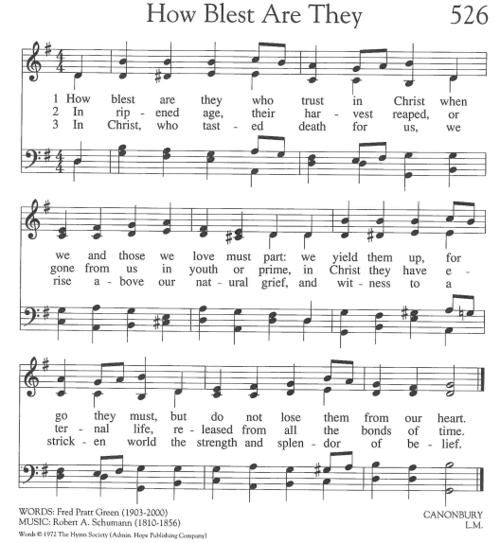
CCLI #1065469

Benediction:
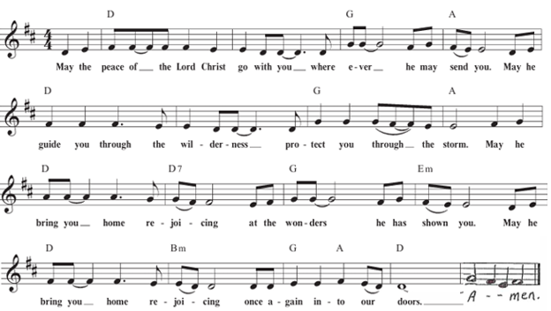

Postlude

*If you are able to do so, please stand

* * * * * * * * * * * * * * * * * * * * *
Chancel Flowers were given by The Ney Family in memory of Vince and Nancy Oddo.

Happy Birthday to: Don Tang (11/03). (Please contact the church office if we have missed your birthday or anniversary.)

Happy Anniversary to: Randy and Darlene Farabaugh (11/02).

Deacon Greeters/Flower Deliveries: Jeff Allison and Pat Patterson.

Most Needed Items for SHIM: Dried beans, lentils, pasta sauce in jars, cereal & oatmeal, soup, condiments, spices, dog and cat food, and personal care items.

SHIM Clothing Closet: Accepting donations of clothes (in season), shoes, and linens (no large household items). Located at the Church of Nazarene (5601 Library Road). Drop-off hours: Mondays 10:00 am until 1:00 pm. If you are not able to deliver your donations during their hours, you can leave them in the closet outside of Findley Hall and a Mission Commission member will deliver them for you.

Hospital visits by Pastor Laura can be scheduled through the church office. If you or someone you know is having surgery or is in the hospital, please let us know so that Pastor Laura can be there to visit and pray with you and your loved ones.

Scheduling a Meeting with Pastor Laura: If you would like to meet with Pastor Laura to discuss a matter that is not a medical or pastoral care emergency, please reach out to her. You can contact her via email at revlaurastrauss@gmail.com or by calling the church office at (412) 561-6261 to schedule a meeting. Dropping in to say “hi” is always appreciated, but scheduling a meeting ensures that Pastor Laura can dedicate the necessary time to your discussion if needed.

PRAYER LIST
(Please contact the church office if you would like to add or update a prayer request.)

Prayer Circle: Mark Tallarico, Christa Jo Tang, Christopher Tang

November: Elsa Jane (Jody Colby’s sister; Infection), Rich Simone (Family of Matt Hricko; Cancer Diagnosis) Ginny Beckstrom (Jill Fako; 100Th Birthday).

October: Ken and Jane Zebrouvis (Ken’s knee surgery), Pastor Laura (Safe travels to Northeast PA), Joe Barton (seizures), Pope Leo (Lung Cancer), Christopher Ropar (Mary Abbott's brother), Dottie Fleming (Illness), The Family of Bernie Gordon, Family of Conrad Sikirica (Cousin of the Obarsky Family), The Stilley Family (student of Ryan Gracey; sudden passing of mom, April; prayers for husband, Jamie, and kids, Alice and Mallory, and nephew/nieces, Nolan, Mae, and Louis), Becker Family (The passing of John Becker, husband and father) Bayles Family, Mental Health Struggles (Mary Abbott), The Family of Dr. Idris Evans (Died in Home Invasion), Evelyn Lape (On-going Home Repair), Mary Thompson (Dottie Fleming's Sister; Surgery), Family of Barry Luokkala (Friend of Jeff Hinkelman), National Hispanic Heritage Month (Lee Cepits; Prayers of Appreciation)

Ongoing – Captain Sam Wright; Ron Sumner; Nancy Brumfield; our mission co-workers at the U.S.-Mexico border, the Rev. Mark Adams and Miriam Maldonado Escobar and their children, Cindy, Anna Flor, and Nathan; our sister church in Malawi, Africa, Litchenza CCAP; our WorldVision child, Pabatso Makhalanyane; and all those who are affected by natural disasters.

ANNOUNCEMENTS

When hymns were written in many years past, there were often additional verses that the writer included. Over the years, those additional verses were left out of later hymnbooks. (Full disclosure here – as the Director of Music, I tend to feel that it can get rather monotonous singing the same tune more than four times, so on occasion, I’ll leave out a verse or two, even if it’s included in the hymnbook.) However, on this All Saints Sunday, I wanted to share some additional verses from our first hymn, “For All the Saints,” as they appear in the Lutheran Service Book. The hymn was written by William Walsham How, sometime in the mid-1800s. There are a total of eight verses – four that we sang this morning – two more that were written at the bottom of the hymnbook page that we didn’t sing – and the additional two verses below.

The golden evening brightens in the west:
soon, soon to faithful warriors comes their rest,
the peaceful calm of paradise the blessed.
Alleluia!

But look! there breaks a yet more glorious day;
saints all-triumphant rise in bright array
the king of glory passes on his way!
Alleluia!

- Welcome Visitors! If you are worshiping here for the first time today, welcome! We are glad to have you with us.

- Offering: The offering is collected following worship by an elder at the back of the sanctuary who will be holding an offering basket. We can also give online by going to shupchurch.org. Our gifts take many forms: open-hearted presence here, voices lifted in song, the prayers that rise in us, the material gifts we share with neighbors, and our willingness to live in a world as allies and advocates for those whose needs are overlooked. The monies we bring symbolize the offering of our lives in all circumstances.

- Advent Adult Sunday School: You're invited to join the Adult Sunday School Class every Sunday at 9:00 a.m. in Findlay Hall. They'll begin studying Matt Rawle's The Redemption of Scrooge on the first Sunday of Advent, November 29. Come prepared to share which film adaptation of the classic story is your favorite and God bless us everyone!

- Book Club: The December meeting will be held on December 2 and we will be discussing West with Giraffes: A Novel by Lynda Rutledge.

- Together for Joy: Giving Sunday, November 15 At SHUP, we have so much to celebrate! Through faithful leadership, generous service, meaningful worship, and ministries that touch lives throughout our community, God continues to do wonderful things among us. As we look toward another year of ministry, we invite you to prayerfully consider your financial pledge for 2027. Every gift helps sustain the life, mission, and joy of our congregation. On Giving Sunday, November 15, we will gather our pledges and dedicate them to God, giving thanks for all we have accomplished together and all that lies ahead. Together, we can continue to make Sunset Hills a place of faith, hope, love, and joy!

- Thanksgiving Dinner: You're invited to join Sunset Hills UP Church for Thanksgiving Dinner on Sunday, November 15 at 5:00 p.m. If your name begins with A-L, bring a side dish. If your name begins with M-Z, bring a dessert. Turkey, stuffing and rolls are provided.

- Hanging of the Greens The Hanging of the Greens will take place following worship on Sunday, November 22. Everyone is invited to stay following worship to prepare the church building for Advent and Christmas.

- Faith and the World: Cookie Chats: You're invited to join Pastor Laura in the church library on the second Sunday of the month at 7:00 p.m. for Cookie Chats. Bring your own beverage and cookies will be provided. The schedule is as follows:
November 8: Christian Nationalism - Can love of country and loyalty to Christ ever come into tension? Let's explore the question together. What happens when religious identity and national identity become difficult to distinguish?
January 10: Loneliness and Belonging - We're living through what some researchers call an epidemic of loneliness. What is loneliness doing to us, and what does the church have that social media, streaming services, and busy schedules cannot provide?

- Ecumenical Community Gathers to Pray Outside ICE Offices: Weekly prayer vigils continue every Friday morning at 8:30 a.m. outside the Immigration & Customs Enforcement (ICE) Office in Pittsburgh's South Side (3000 Sidney St, 15203). Facilitated by a different faith community each week, the vigil is a legal, peaceful witness of support for local immigrants. People of all faith backgrounds are welcome and Presbyterians are always represented well.

- Articles for The Messenger: If you plan on submitting an article for The Messenger, please do so by the 15th of each month.


Welcome to
Sunset Hills
United Presbyterian Church
Phone: 412-561-6261
Office hours: Monday, Tuesday, Thursday, 9:00 am – 2:00 pm
900 Country Club Dr. Pittsburgh, PA 15228
www.shupchurch.org

CHURCH CALENDAR

Sunday, November 1
9:00 am – Adult Sunday School–Findley
9:00 am – Children’s Sunday School
10:15 am – Worship – Sanctuary
10:45 am – Children’s Church – Rm 113
2:00 pm – Girl Scouts

Monday, November 2
9:00 am – Monday Marvels
1:00 pm – Women’s Bible Study
6:00 pm – Girl Scouts Troop 46920

Tuesday, November 3
12:30 pm – Tuesday Bible Study
7:00 pm – Handbell Choir
7:00 pm – Square Dance Club – Crystal
7:00 pm – Counseling Group–Marvel’s Lounge
7:30 pm – Choir

Wednesday, November 4
10:00 am – Days for Girls
2:00 pm – Parkinson’s Exercise Group
4:00 pm – Quilters

Thursday, November 5
6:15pm – Fall Yoga

Friday, November 6
5:00 pm – AA

Sunday, November 8
9:00 am – Adult Sunday School–Findley
9:00 am – Children’s Sunday School
10:15 am – Worship – Sanctuary
10:45 am – Children’s Church – Rm 113
2:00 pm – Girl Scouts
4:00 pm – Girl Scouts Troop 16212
7:00 pm – Faith and the World: Cookie Chats

