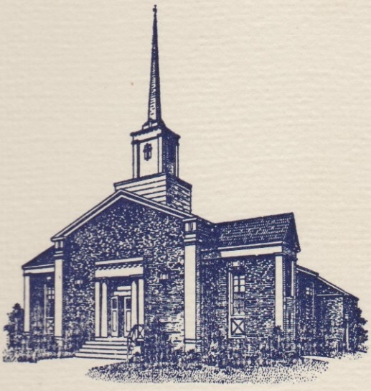
Sunset Hills United
Presbyterian Church
900 Country Club Drive
Pittsburgh, PA 15228
www.shupchurch.org
10:15 am WORSHIP
July 19, 2026
8th Sunday After Pentecost

IN PREPARATION FOR WORSHIP

"The most useful knowledge is to know that we've been deceived, and the most delightful discovery is to find out that we've been mistaken. 'Capable of forsaking an error--this is fine praise, and a fine quality."
-Joseph Joubert, French Writer

ENTERING GOD’S PRESENCE

Prelude

Announcements

Lighting of the Christ Candle

Prayer of Preparation

Introit: Glorify Thy Name D. Adkins
Father, we love You, we worship and adore You,
Glorify Thy name in all the earth.
Glorify Thy name, Glorify Thy name,
Glorify Thy name in all the earth.
CCLI #1065469

Call to Worship: Liturgist: Linda DeBor
Leader: This is the day the Lord has made.
People: We will rejoice and be glad in it.
Leader: We come from busy weeks and scattered thoughts.
People: God gathers us in.
Leader: We come with questions, with hope, with ordinary faith.
People: God meets us here.
Leader: Let us worship the One who speaks life, who calls us by name, and who is faithful in every season.
People: Let us worship God.

Hymn: When Morning Gilds the Skies No. 487

*Call to Confession:
With humble and trusting hearts, let us confess our sins before God and one another.

*Prayer of Confession:
Gracious God, we confess that we do not always come to you with open hearts. We cling to distractions. We rehearse old worries. We resist new insight. We prefer what is comfortable over what is transforming. Forgive us. Quiet the noise within us. Soften our assumptions. Make us ready to hear your Word— even when it surprises us. In Christ’s mercy we pray. Amen.

*Assurance of Pardon:
Leader: Hear the good news: God is not waiting for you to get it all together. God meets you here — as you are. In Jesus Christ, you are forgiven. In the Spirit, you are being renewed. Thanks be to God.
People: Alleluia! Amen.

*Response: The Gloria
Now let our voices raise; Alleluia! Amen!
To give to God our praise; Alleluia! Amen!
Mercy and grace abound! In God our lives are found!
Long may our joy resound; Alleluia! Amen!

*The Passing of the Peace, American Sign Language
Leader: Peace be with you.
People: And also with you.

Anthem: Come with Joyful Singing J. Martin
(SHUP Chancel Choir Recording)

(Chorus)
Come with joyful singing, come with joyful singing,
Come with joyful singing and songs of praise.
Come with joyful singing, come with joyful singing,
Come with joyful singing and songs of praise.

Alleluia, alleluia, this is the day that our God has made.
Alleluia, alleluia, respond with tuneful praise!
Rejoice and fill every heart with praise,
Let every voice be raised.
Come before God with an alleluia.

(Chorus)

This is our purpose, this is our song,
Proclaiming our Savior with voices strong.
For God is worthy, worthy of honor.
Our God is worthy of our worship.
We offer all our praise! We pledge to you our days.
As one we lift a joyous alleluia!

(Chorus)

Alleluia, alleluia, this is the day that our God has made.
Alleluia, alleluia, respond with tuneful praise!
Rejoice and fill every heart with praise,
Let every voice be raised.
Come before God with an alleluia.

(Chorus)
CCLI #1065469

HEARING GOD’S WORD

Hymn: Jesus Loves Me!

Children’s Story Time

Scripture Readings:

Old Testament: Genesis 2:4-9
⁴ These are the generations of the heavens and the earth when they were created.In the day that the Lord^{[a]} God made the earth and the heavens, ⁵ when no plant of the field was yet in the earth and no herb of the field had yet sprung up—for the Lord God had not caused it to rain upon the earth, and there was no one to till the ground; ⁶ but a stream would rise from the earth, and water the whole face of the ground— ⁷ then the Lord God formed man from the dust of the ground,^{[b]} and breathed into his nostrils the breath of life; and the man became a living being. ⁸ And the Lord God planted a garden in Eden, in the east; and there he put the man whom he had formed. ⁹ Out of the ground the Lord God made to grow every tree that is pleasant to the sight and good for food, the tree of life also in the midst of the garden, and the tree of the knowledge of good and evil.

New Testament: Romans 5: 12-19
¹² Therefore, just as sin came into the world through one man, and death came through sin, and so death spread to all because all have sinned— ¹³ sin was indeed in the world before the law, but sin is not reckoned when there is no law. ¹⁴ Yet death exercised dominion from Adam to Moses, even over those whose sins were not like the transgression of Adam, who is a type of the one who was to come.
¹⁵ But the free gift is not like the trespass. For if the many died through the one man’s trespass, much more surely have the grace of God and the free gift in the grace of the one man, Jesus Christ, abounded for the many. ¹⁶ And the free gift is not like the effect of the one man’s sin. For the judgement following one trespass brought condemnation, but the free gift following many trespasses brings justification. ¹⁷ If, because of the one man’s trespass, death exercised dominion through that one, much more surely will those who receive the abundance of grace and the free gift of righteousness exercise dominion in life through the one man, Jesus Christ.
¹⁸ Therefore just as one man’s trespass led to condemnation for all, so one man’s act of righteousness leads to justification and life for all. ¹⁹ For just as by the one man’s disobedience the many were made sinners, so by the one man’s obedience the many will be made righteous.

Leader: The Word of the Lord!
People: Thanks be to God.

Sermon Elder Chip McCoy

Hymn: Be Thou My Vision No. 339

RESPONDING TO GOD’S WORD

Affirmation of Faith: The Nicene Creed
We believe in one God, the Father, the Almighty, maker of heaven and earth, of all that is seen and unseen. We believe in one Lord, Jesus Christ, the only Son of God, eternally begotten of the Father, God from God, Light from Light, true God from true God, begotten, not made, of one Being with the Father. Through him all things were made. For us and for our salvation he came down from heaven; by the power of the Holy Spirt he became incarnate from the Virgin Mary and was made man. For our sake he was crucified under Pontius Pilate; he suffered death and was buried. On the third day he rose again in accordance with the Scriptures; he ascended into heaven and is seated at the right hand of the Father. He will come again in glory to judge the living and the dead, and his kingdom will have no end. We believe in the Holy Spirit, the Lord, the giver of life, who proceeds from the Father and the Son. With the Father and the Son he is worshipped and glorified. He has spoken through the Prophets. We believe in only holy catholic and apostolic Church. We acknowledge one baptism for the forgiveness of sins. We look for the resurrection of the dead, and the life of the world to come. Amen.

Joys, Concerns, & Testimonies

Prayers of the People & The Lord’s Prayer
Our Father who art in heaven, hallowed be thy name.
Thy kingdom come, thy will be done, on earth as it is in heaven.
Give us this day our daily bread;
and forgive us our debts, as we forgive our debtors;
and lead us not into temptation, but deliver us from evil.
For thine is the kingdom and the power and the glory, forever. Amen.

Presenting Gifts, Tithes and Offerings

Prayer of Dedication

*Response: Doxology
Praise God, from whom all blessings flow;
Praise Him, all creatures here below;
Praise Him above, ye heav’nly host;
Praise Father, Son, and Holy Ghost. Amen.

DEPARTING TO SERVE

Hymn: Called as Partners in Christ’s Service No. 343

Benediction: (To be sung)
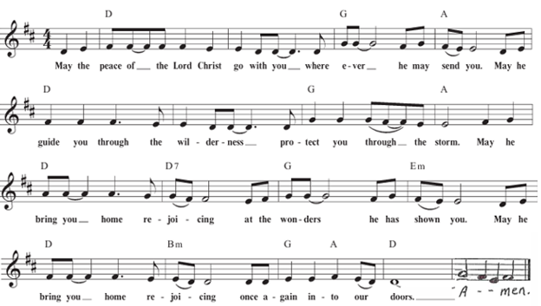

*Postlude
*If you are able to do so, please stand

* * * * * * * * * * * * * * * * * * * * *

Many thanks to Chip McCoy for leading us in worship today while Pastor Laura is on the mission trip, and to Carla Robinson for leading this morning’s music while Shelby is on vacation.
Chancel Flowers were given by the Rickard Family in memory of their parents and grandparents.

Happy Birthday to: Lucy Tang (07/23), Matthew Hricko (07/25) (Please contact the church office if we have missed your birthday or anniversary.)

Happy Anniversary to: Jeff Hinkelman & Hannah Rosen. (07/19), John and Bella Ellis (07/24).

Deacon Greeters/Flower Deliveries: Mike Duffner and Jonathan Fako.

Most Needed Items for SHIM: Dried beans, lentils, pasta sauce in jars, cereal & oatmeal, soup, condiments, spices, adult diapers, baby diapers (size 4-6), dog and cat food, and personal care items.

SHIM Clothing Closet: Accepting donations of clothes (in season), shoes, and linens (no large household items). Located at the Church of Nazarene (5601 Library Road). Drop-off hours: Mondays 10:00 am until 1:00 pm. If you are not able to deliver your donations during their hours, you can leave them in the closet outside of Findley Hall and a Mission Commission member will deliver them for you.

Hospital visits by Pastor Laura can be scheduled through the church office. If you or someone you know is having surgery or is in the hospital, please let us know so that Pastor Laura can be there to visit and pray with you and your loved ones.

Scheduling a Meeting with Pastor Laura: If you would like to meet with Pastor Laura to discuss a matter that is not a medical or pastoral care emergency, please reach out to her. You can contact her via email at revlaurastrauss@gmail.com or by calling the church office at (412) 561-6261 to schedule a meeting. Dropping in to say “hi” is always appreciated, but scheduling a meeting ensures that Pastor Laura can dedicate the necessary time to your discussion if needed.

PRAYER LIST
(Please contact the church office if you would like to add or update a prayer request.)

Prayer Circle: Pat Patterson and Jan Paulsen.

July: Evelyn Lape (broken foot)

June: Bev Knasko (continued recovery from CDiff), Venerina Deioloius (John Ellis, III's mother-in-law), Family of Joan Greenaway (Linda DeBor’s sister) Ron Sumner (Amy Sumner's husband, cancer), Rev. Elizabeth Wallace (Pastor Laura's friend; breast cancer and sepsis).

Ongoing –Ron Sumner; Nancy Brumfield; our mission co-workers at the U.S.-Mexico border, the Rev. Mark Adams and Miriam Maldonado Escobar and their children, Cindy, Anna Flor, and Nathan; our sister church in Malawi, Africa, Litchenza CCAP; our WorldVision child, Pabatso Makhalanyane; and all those who are affected by natural disasters.

ANNOUNCEMENTS

- Welcome Visitors! If you are worshiping here for the first time today, welcome! We are glad to have you with us.

- Offering: The offering is collected following worship by an elder at the back of the sanctuary who will be holding an offering basket. We can also give online by going to shupchurch.org. Our gifts take many forms: open-hearted presence here, voices lifted in song, the prayers that rise in us, the material gifts we share with neighbors, and our willingness to live in a world as allies and advocates for those whose needs are overlooked. The monies we bring symbolize the offering of our lives in all circumstances.

- Adult Sunday School will be studying Amy-Jill Levine's The Bible With and Without Jesus: How Jews and Christians Read the Same Texts Differently beginning Sunday, June 14. Esteemed Bible scholars and teachers Amy-Jill Levine and Marc Z. Brettler take readers on a guided tour of the most popular Hebrew Bible passages quoted in the New Testament to show what the texts meant in their original contexts and then how Jews and Christians, over time, understood those same texts. Passages include the creation of the world, the role of Adam and Eve, the Suffering Servant of Isaiah, the book of Jonah, and Psalm 22, whose words, “My God, my God, why have you forsaken me,” Jesus quotes as he dies on the cross. Adult Sunday School meets every Sunday at 9:00 a.m.

- Get to know, Chip McCoy, (Wayne L. McCoy, Jr.)
Retired Air Force Colonel, in the Intelligence field, living on family farm in Independence Township. Logger, sawyer, furniture maker. Married to Susanne (Kurz), two children (Benjamin and Katherine). Three grandchildren: Kennedy, Cameron and Caleb.

- Volunteers Needed for VBS! Our VBS this year will be held August 3–7, with the theme of Rainforest Falls. We’re looking forward to having another great group of kids this year, and will need lots of volunteers in various areas. Please let Pastor Laura know if you’re able to help in this important neighborhood outreach!

- Ecumenical Community Gathers to Pray Outside ICE Offices Weekly prayer vigils continue every Friday morning at 8:30 a.m. outside the Immigration & Customs Enforcement (ICE) Office in Pittsburgh's South Side (3000 Sidney St, 15203). Facilitated by a different faith community each week, the vigil is a legal, peaceful witness of support for local immigrants. People of all faith backgrounds are welcome and Presbyterians are always represented well.

- Read the New Testament in ’26: A Bible reading and discussion group is taking place at 6:30 pm, at the home of Jeff Alllison. Call or text Jeff at 412-780-3787 for details and sign-ups.

- Book Club: The July meeting will be held July 29 and we will be discussing Stephanie Dray and Laura Kamoie's novel, America's First Daughter.

- Refugee Youth in need! Do you have space in your heart and home for a Refugee Youth in need? Bethany Christian Services’ Refugee Foster Care Program is currently looking for foster homes for Refugee Youth between the ages of 12-17. The children in the program do not have family reunification possibilities and are in desperate need of long-term, loving placements. The majority of the children are Christian/Catholic youth arriving from Central and South America. The children all have legal status in the United States and a pathway to US Citizenship. If you are interested in learning more, please contact Annelise Halstead at annelisehalstead@bethany.org or visit our website at www.bethany.org/refugeefostercare

- Pet Blessing: All species welcome on a leash or in a carrier. There will be Blessings, food, games and fun for the whole family on August 30th from 6-8pm. We look forward to meeting you and your pet!

- Articles for The Messenger: If you plan on submitting an article for The Messenger, please do so by the 15th of each month.



Welcome to
Sunset Hills
United Presbyterian Church
Phone: 412-561-6261
Office hours: Monday – Thursday, 9:00 am – 3:00 pm
900 Country Club Dr. Pittsburgh, PA 15228
www.shupchurch.org

CHURCH CALENDAR

Sunday, July 19
10:15 am – Worship–Sanctuary
10:45 am – Children’s Church–Room 113
11:15 am – Fellowship Hour
2:00 pm – Girl Scouts
6:00 pm – AA

Monday, July 20
9:00 am – Monday Morning Marvels

Tuesday, July 21
7:00 pm – Square Dance Club – Crystal
7:00 pm – Counseling Group–Marvel’s Lounge

Wednesday, July 22
10:00 am – Days for Girls
2:00 pm – Parkinson’s Exercise Group

Thursday, July 23
10:00 am – Quilters

Friday, July 24
5:00 pm – AA

Sunday, July 26
9:00 am – Adult Sunday School–Findley
9:00 am – Children’s Sunday School
10:15 am – Worship – Sanctuary
10:45 am – Children’s Church – Rm 113
2:00 pm – Girl Scouts
6:00 pm – AA

