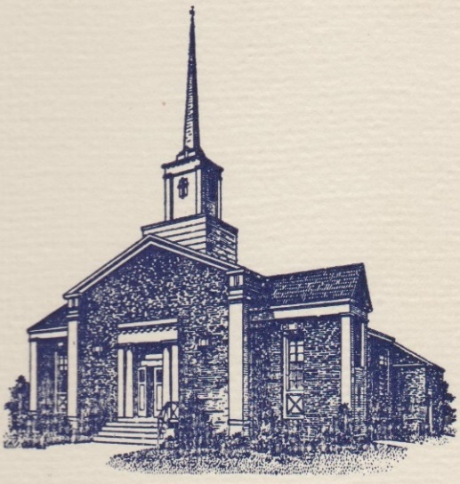
Sunset Hills United
Presbyterian Church
900 Country Club Drive
Pittsburgh, PA 15228
www.shupchurch.org
10:15 am WORSHIP
October 4, 2026
19th Sunday After Pentecost

IN PREPARATION FOR WORSHIP

“We are mystically united to one another and to Christ through baptism. We are a body. We owe each other a duty of love—that supreme test of faith.”
– Esau McCaulley, New Testament Scholar

“For in the one Spirit we were all baptized into one body.”
– 1 Corinthians 12:13

ENTERING GOD’S PRESENCE

Announcements

Lighting of the Christ Candle

Prayer of Preparation

Introit: Surely the Presence of the Lord L. Wolfe
Surely the presence of the Lord is in this place.
I can feel His mighty power and His grace.
I can hear the brush of angels’ wings,
I see glory on each face.
Surely the presence of the Lord is in this place.
CCLI #1065469

Call to Worship: Liturgist: Tim Fako

One: Jesus says, “The hour is coming, and is now here.”
All: We come attentive to what God is doing among us.
One: Christ speaks, and even the places of death hear his voice.
All: We come trusting in the God who calls forth life.
One: We do not understand every mystery, nor do we need to. We come with our faith and our questions, our hope and our uncertainty.
All: Come, let us listen for the voice of Christ and worship the God of life.

Hymn: In Christ There Is No East or West No. 439

*Call to Confession:
There is much about God we do not know. Yet too often we substitute certainty for faith, judgment for curiosity, and fear for trust. Before the God who knows us completely and loves us still, let us confess our sin. Let us pray together with the prayer of confession.

*Prayer of Confession:
God of life, forgive us when we pretend to know what belongs to you alone. We divide the world into the worthy and unworthy. We judge what we cannot see. We condemn what we do not understand. Sometimes we become so certain about others that we stop listening for you. Call us out of the tombs we have made: out of fear, out of self-righteousness, out of old resentments, out of everything that keeps us from the abundant life you desire. Speak again, O Christ. We are listening.
Amen.

*Assurance of Pardon:
One: Hear the good news: the voice of Christ is a voice that calls us from death into life. Grace is already at work, loosening what binds us. In Jesus Christ, we are forgiven.

All: Thanks be to God. Amen.

*Response Alleluia!
All creatures, your Creator bless,
And worship God in humbleness.
O sing ye! Alleluia!
Praise, praise the Father, praise the Son,
And praise the Spirit, Three in One!
O sing ye! Alleluia!
Alleluia! Alleluia! Alleluia!
*The Passing of the Peace
Leader: Peace be with you.
People: And also with you.

Anthem: One World, One Communion P. Choplin

HEARING GOD’S WORD

Hymn: Jesus Loves Me!

Children’s Story Time

The Sacrament of Baptism Natalie Obarsky and Daisy Martin

Hymn of Blessing: Good Shepherd, Take These Little Ones C. Cloninger
(Tune: The Lord’s My Shepherd)
Good Shepherd, take these little ones into your loving hands;
And in the days that lie ahead protect these little lambs.

Good Shepherd, now we place them both into your gentle trust;
This precious gift we give to you is one you’ve given us.

Good Shepherd, we commit ourselves in everything we do
To be your family here on earth and love these kids for you.
CCLI #1065469

Scripture Readings:

Gospel: John 5:25-29
²⁵ ‘Very truly, I tell you, the hour is coming, and is now here, when the dead will hear the voice of the Son of God, and those who hear will live. ²⁶ For just as the Father has life in himself, so he has granted the Son also to have life in himself; ²⁷ and he has given him authority to execute judgement, because he is the Son of Man. ²⁸ Do not be astonished at this; for the hour is coming when all who are in their graves will hear his voice ²⁹ and will come out—those who have done good, to the resurrection of life, and those who have done evil, to the resurrection of condemnation.

Leader: The Word of the Lord!
People: Thanks be to God.

Sermon The Eternal Voice Rev. Dr. Laura Strauss

Hymn: Let Us Break Bread Together No. 513

Sacrament of Holy Communion
The Invitation
The Great Thanksgiving
Pastor: The Lord be with you.
People: And also with you.
Pastor: Lift up your hearts.
People: We lift them up to the Lord.
Pastor: Let us give thanks to the Lord our God.
People: It is right to give Him thanks and praise.
Pastoral Prayer
Holy, holy, holy Lord, God of power and might,
heaven and earth are full of your glory.
Hosanna in the highest.
Blessed is he who comes in the name of the Lord.
Hosanna in the highest.

The Lord’s Prayer
Our Father who art in heaven, hallowed be thy name.
Thy kingdom come, thy will be done, on earth as it is in heaven.
Give us this day our daily bread;
and forgive us our debts, as we forgive our debtors;
and lead us not into temptation, but deliver us from evil.
For thine is the kingdom and the power and the glory, forever. Amen.

The Words of Institution
The Sharing of the Bread
The Sharing of the Cup
The Prayer of Thanksgiving

RESPONDING TO GOD’S WORD

Affirmation of Faith: From A Brief Statement of Faith
In life and in death we belong to God. Through the grace of our Lord Jesus Christ, the love of God, and the communion of the Holy Spirit, we trust in the one triune God, the Holy One of Israel, whom alone we worship and serve…With believers in every time and place, we rejoice that nothing in life or in death can separate us from the love of God in Christ Jesus our Lord. Glory be to the Father, and to the Son, and to the Holy Spirit. Amen.

Joys, Concerns, & Testimonies

Presenting Gifts, Tithes and Offerings

Prayer of Dedication

*Response: Doxology
Praise God, from whom all blessings flow;
Praise Him, all creatures here below;
Praise Him above, ye heav’nly host;
Praise Father, Son, and Holy Ghost. Amen.

DEPARTING TO SERVE
Hymn: As We Gather at Your Table Insert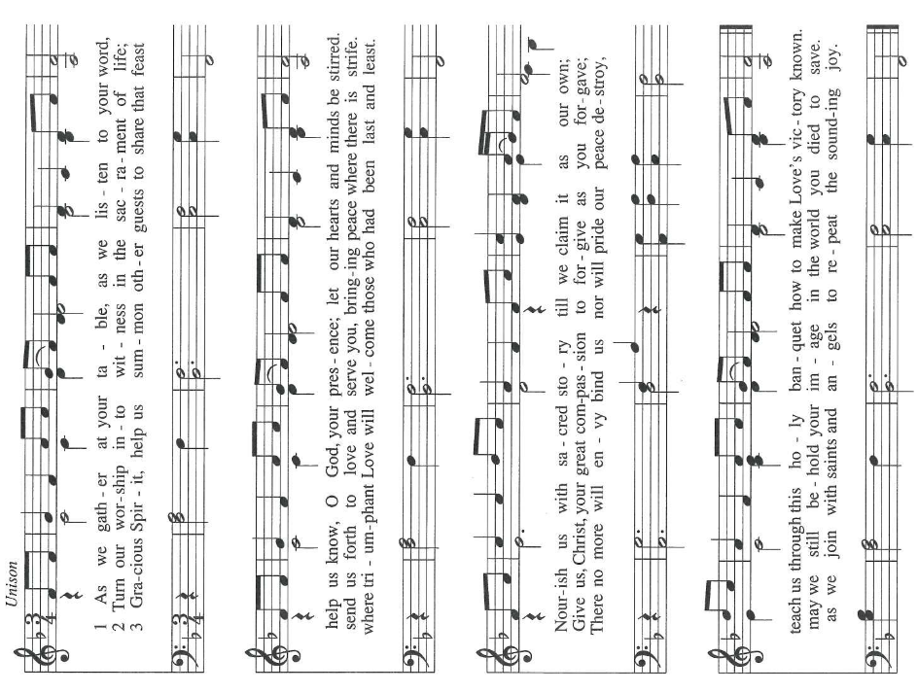
CCLI #1065469

Benediction:
May the peace of the Lord Christ go with you; wherever he may send you; may he guide you through the wilderness; protect you through the storm; may he bring you home rejoicing; at the wonders he has shown you; may he bring you home rejoicing; once again into our doors.
Response: God Be With You
God be with you till we meet again,
loving counsels guide, uphold you,
With a Shepherd’s care enfold you;
God be with you till we meet again.

*Postlude
*If you are able to do so, please stand

* * * * * * * * * * * * * * * * * * * * *

Chancel Flowers were given by Harriet Ross in memory of Jim Ross.

Happy Birthday to: Marla Bruschi (10/5). (Please contact the church office if we have missed your birthday or anniversary.)

Happy Anniversary to: There are no anniversaries at this time.

Deacon Greeters/Flower Deliveries: Darlene Farabaugh and Pat Patterson.

Most Needed Items for SHIM: Dried beans, lentils, pasta sauce in jars, cereal & oatmeal, soup, condiments, spices, dog and cat food, and personal care items.

SHIM Clothing Closet: Accepting donations of clothes (in season), shoes, and linens (no large household items). Located at the Church of Nazarene (5601 Library Road). Drop-off hours: Mondays 10:00 am until 1:00 pm. If you are not able to deliver your donations during their hours, you can leave them in the closet outside of Findley Hall and a Mission Commission member will deliver them for you.

Hospital visits by Pastor Laura can be scheduled through the church office. If you or someone you know is having surgery or is in the hospital, please let us know so that Pastor Laura can be there to visit and pray with you and your loved ones.

Scheduling a Meeting with Pastor Laura: If you would like to meet with Pastor Laura to discuss a matter that is not a medical or pastoral care emergency, please reach out to her. You can contact her via email at revlaurastrauss@gmail.com or by calling the church office at (412) 561-6261 to schedule a meeting. Dropping in to say “hi” is always appreciated, but scheduling a meeting ensures that Pastor Laura can dedicate the necessary time to your discussion if needed.

PRAYER LIST
(Please contact the church office if you would like to add or update a prayer request.)

Prayer Circle: Ethan Strauss, Fritz Strauss, Laura Strauss

October: The Stilley Family (student of Ryan Gracey; sudden passing of mom, April; prayers for husband, Jamie, and kids, Alice and Mallory, and nephew/nieces, Nolan, Mae, and Louis), Becker Family (The passing of John Becker, husband and father) Bayles Family, Mental Health Struggles (Mary Abbott) The Family of Dr. Idris Evans (Died in Home Invasion), Evelyn Lape (On-going Home Repair), Mary Thompson (Dottie Fleming's Sister; Surgery), Family of Barry Luokkala (Friend of Jeff Hinkelman), National Hispanic Heritage Month (Lee Cepits; Prayers of Appreciation)

September: Dorene Hirshika (passing of mom; friend of Darlene Farabaugh), Alecia and Dave Marney (celebration of marriage, Sept. 12, 2026), Linda (car accident, friend of LoAnn Burian), Tom (friend of Rosalie Pillitteri), The Rabbani Family (Granddaughter born with heart problems. Neighbors of the Fako Family.), Evelyn Lape (Damage to her home from the recent storm.), The Brady Family (Damage to their home from the recent storm, Carol Noonan’s neighbor), Lucy Josephine Escobar (new grandchild of Keith and Wendy Yanda, daughter of Michelle (Yanda) and Daniel Escobar), born August 28 in Santa Cruz, CA.

Ongoing – Captain Sam Wright; Ron Sumner; Nancy Brumfield; our mission co-workers at the U.S.-Mexico border, the Rev. Mark Adams and Miriam Maldonado Escobar and their children, Cindy, Anna Flor, and Nathan; our sister church in Malawi, Africa, Litchenza CCAP; our WorldVision child, Pabatso Makhalanyane; and all those who are affected by natural disasters.

ANNOUNCEMENTS

- With Gratitude: We give thanks to the Rev. Dr. Bill Gracey, our Pastor Emeritus, for joining us in worship today and for sharing in the Sacrament of Baptism as he baptizes his granddaughter, Natalie. What a joy to welcome him back to the font where he once baptized and welcomed so many into the family of faith—and what a gift to witness this new generation received with the same promises of grace and belonging!

- Welcome Visitors! If you are worshiping here for the first time today, welcome! We are glad to have you with us.

- Offering: The offering is collected following worship by an elder at the back of the sanctuary who will be holding an offering basket. We can also give online by going to shupchurch.org. Our gifts take many forms: open-hearted presence here, voices lifted in song, the prayers that rise in us, the material gifts we share with neighbors, and our willingness to live in a world as allies and advocates for those whose needs are overlooked. The monies we bring symbolize the offering of our lives in all circumstances.

- SHUP Flu & COVID Shot Clinic: SHUP’s annual Flu & COVID Shot Clinic will be held on Sunday, October 25, immediately following worship. Immunizations offered will include Flu, Flu HD, COVID, Pneumonia, RSV, and Shingles. If you receive your first Shingles shot at the clinic, you will need to follow up with Pathways for your second dose. Please take advantage of this convenient opportunity to stay up to date on your vaccinations!

- Winter Clothing Swap: All are welcome to shop the Winter Clothing Swap on Saturday, October 10th! Donations will be accepted from October 1–9 at Wonderfill, the Mt. Lebanon Library, and Rolliers, as well as at the event. Winter clothing of all kinds is welcome, including coats, sweaters, sweatshirts, gloves, hats, and more. Please donate only items in good condition. Come find something warm and share the warmth with others!

- Ecumenical Community Gathers to Pray Outside ICE Offices Weekly prayer vigils continue every Friday morning at 8:30 a.m. outside the Immigration & Customs Enforcement (ICE) Office in Pittsburgh's South Side (3000 Sidney St, 15203). Facilitated by a different faith community each week, the vigil is a legal, peaceful witness of support for local immigrants. People of all faith backgrounds are welcome and Presbyterians are always represented well.

- Book Club: The September meeting will be held October 28 and we will be discussing A Burning in My Bones: The Authorized Biography of Eugene H. Peterson by Winn Collier.

- Children's Collection: Thank you everyone for your generosity. Because of you, we are able to purchase a wheelchair through World Vision. We will be collecting for a new item next Sunday, October 11th.

- Faith and the World: Cookie Chats: You're invited to join Pastor Laura in the church library on the second Sunday of the month at 7:00 p.m. for Cookie Chats. Bring your own beverage and cookies will be provided. The schedule is as follows:
October 11: Death and Dying - Most of us avoid talking about death until we can't. Let's explore what the Christian faith has to say about mortality, grief, and hope. From funeral homes to resurrection hope, how does the Christian story help us face death?
November 8: Christian Nationalism - Can love of country and loyalty to Christ ever come into tension? Let's explore the question together. What happens when religious identity and national identity become difficult to distinguish?
January 10: Loneliness and Belonging - We're living through what some researchers call an epidemic of loneliness. What is loneliness doing to us, and what does the church have that social media, streaming services, and busy schedules cannot provide?

- Articles for The Messenger: If you plan on submitting an article for The Messenger, please do so by the 15th of each month.


Welcome to
Sunset Hills
United Presbyterian Church
Phone: 412-561-6261
Office hours: Monday, Tuesday, Thursday, 9:00 am – 2:00 pm
900 Country Club Dr. Pittsburgh, PA 15228
www.shupchurch.org

CHURCH CALENDAR

Sunday, October 4
9:00 am – Adult Sunday School–Findley
9:00 am – Children’s Sunday School
10:15 am – Worship – Sanctuary
10:45 am – Children’s Church – Rm 113
2:00 pm – Girl Scouts

Monday, October 5
9:00 am – Monday Marvels
1:00 pm – Women’s Bible Study

Tuesday, October 6
10:00 am – Staff Meeting
12:30 pm – Tuesday Bible Study
6:30 pm – Handbell Choir
7:00 pm – Square Dance Club – Crystal
7:00 pm – Counseling Group–Marvel’s Lounge
7:30 pm – Choir

Wednesday, October 7
10:00 am – Days for Girls
2:00 pm – Parkinson’s Exercise Group
4:00 pm – Quilters

Thursday, October 8
6:15 pm – Fall Yoga

Friday, October 9
5:00 pm – AA

Sunday, October 11
9:00 am – Adult Sunday School–Findley
9:00 am – Children’s Sunday School
10:15 am – Worship – Sanctuary
10:45 am – Children’s Church – Rm 113
2:00 pm – Girl Scouts
4:00 pm – Girl Scouts Troop 16212
7:00 pm – Faith and the World: Cookie Chats
