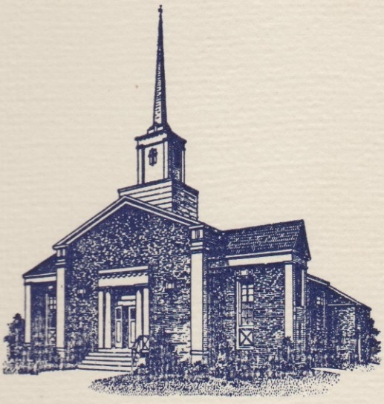
Sunset Hills United
Presbyterian Church
900 Country Club Drive
Pittsburgh, PA 15228
www.shupchurch.org
10:15 am WORSHIP
July 26, 2026
9th Sunday After Pentecost

IN PREPARATION FOR WORSHIP

"Before a word is on my tongue, O Lord, you know it completely.".
–Psalm 139:4

"Sometimes all we can offer is our presence and our pain. God does not ask us to turn them into certainty. God does not wait for us to find the right words."
–Kate Bowler, Contemporary Theologian

ENTERING GOD’S PRESENCE

Prelude

Announcements

Lighting of the Christ Candle

Prayer of Preparation

Introit: Glorify Thy Name D. Adkins
Father, we love You, we worship and adore You,
Glorify Thy name in all the earth.
Glorify Thy name, Glorify Thy name,
Glorify Thy name in all the earth.
CCLI #1065469

Call to Worship: Liturgist: Marla Bruschi
Leader: When we do not know how to pray –
People: The Holy Spirit prays for us.
Leader: When words fail and sighs are all we have –
People: God hears.
Leader: When life feels uncertain –
People: God is at work for good.
Leader: When fear rises –
People: Nothing can separate us from the love of God.
Leader: Come and worship the God whose love holds fast.
People: We come to worship the Lord of steadfast love.

Hymn: From All that Dwell Below the Skies No. 229

*Call to Confession:
The truth about us is this: we all sin and fall short of the glory of God. Yet God promises to pour out grace upon us, giving us confidence to show ourselves as we are and be freed from shame. Trusting in God’s mercy, let us confess our sin before God and one another.

*Prayer of Confession:
Faithful God, we confess that we often live as though your love were fragile. We let anxiety take over. We believe the lie that hardship means you have left us. When suffering comes, we assume punishment. When prayers feel unanswered, we assume silence. When life feels uncertain, we assume the worst. Forgive us. Remind us that your love does not depend on our strength. Remind us that your Spirit intercedes when we cannot speak. Remind us that in Christ, we are held. We pray this in his holy name. Amen.

*Assurance of Pardon:
Leader: Hear the good news: “If God is for us, who is against us?” In Christ, you are forgiven. In Christ, you are claimed. In Christ, you are more than conquerors – not because you are strong, but because God’s love is. Nothing – not trouble, not hardship, not fear, not even death – can separate you from the love of God in Christ Jesus our Lord. Thanks be to God.

*Response: The Gloria
Now let our voices raise; Alleluia! Amen!
To give to God our praise; Alleluia! Amen!
Mercy and grace abound! In God our lives are found!
Long may our joy resound; Alleluia! Amen!

*The Passing of the Peace, American Sign Language
Leader: Peace be with you.
People: And also with you.

Cello Solo: The Angel Gabriel from Heaven Came Down S. Baring-Gould
(Guest celloist: Declan Rooney)

HEARING GOD’S WORD

Hymn: Jesus Loves Me!

Children’s Story Time

Scripture Readings:

Old Testament: Psalm 119:129-136
¹²⁹Your decrees are wonderful;
therefore my soul keeps them.
¹³⁰ The unfolding of your words gives light;
it imparts understanding to the simple.
¹³¹ With open mouth I pant,
because I long for your commandments.
¹³² Turn to me and be gracious to me,
as is your custom towards those who love your name.
¹³³ Keep my steps steady according to your promise,
and never let iniquity have dominion over me.
¹³⁴ Redeem me from human oppression,
that I may keep your precepts.
¹³⁵ Make your face shine upon your servant,
and teach me your statutes.
¹³⁶ My eyes shed streams of tears
because your law is not kept.

New Testament: Romans 8:26-39
²⁶ Likewise the Spirit helps us in our weakness; for we do not know how to pray as we ought, but that very Spirit intercedes with sighs too deep for words. ²⁷ And God, who searches the heart, knows what is the mind of the Spirit, because the Spirit intercedes for the saints according to the will of God.
²⁸ We know that all things work together for good for those who love God, who are called according to his purpose. ²⁹ For those whom he foreknew he also predestined to be conformed to the image of his Son, in order that he might be the firstborn within a large family. ³⁰ And those whom he predestined he also called; and those whom he called he also justified; and those whom he justified he also glorified.
³¹ What then are we to say about these things? If God is for us, who is against us? ³² He who did not withhold his own Son, but gave him up for all of us, will he not with him also give us everything else? ³³ Who will bring any charge against God’s elect? It is God who justifies. ³⁴ Who is to condemn? It is Christ Jesus, who died, yes, who was raised, who is at the right hand of God, who indeed intercedes for us. ³⁵ Who will separate us from the love of Christ? Will hardship, or distress, or persecution, or famine, or nakedness, or peril, or sword? ³⁶ As it is written, ‘For your sake we are being killed all day long; we are accounted as sheep to be slaughtered.’
³⁷ No, in all these things we are more than conquerors through him who loved us. ³⁸ For I am convinced that neither death, nor life, nor angels, nor rulers, nor things present, nor things to come, nor powers, ³⁹ nor height, nor depth, nor anything else in all creation, will be able to separate us from the love of God in Christ Jesus our Lord.

Leader: The Word of the Lord!
People: Thanks be to God.

Sermon Rev. Dr. Laura Strauss

Hymn: There’s a Wideness in God’s Mercy (Tune: Hear the Good News…) No. 298

RESPONDING TO GOD’S WORD

Affirmation of Faith: The Confession of 1967, 9.17
Christ is head of this community, the church, which began with the apostles and continues through all generations. The church is called to be a sign in and for the world of the new reality which God has made available to people in Jesus Christ. Amen.

Joys, Concerns, & Testimonies

Prayers of the People & The Lord’s Prayer
Our Father who art in heaven, hallowed be thy name.
Thy kingdom come, thy will be done, on earth as it is in heaven.
Give us this day our daily bread;
and forgive us our debts, as we forgive our debtors;
and lead us not into temptation, but deliver us from evil.
For thine is the kingdom and the power and the glory, forever. Amen.

Presenting Gifts, Tithes and Offerings

Prayer of Dedication

*Response: Doxology
Praise God, from whom all blessings flow;
Praise Him, all creatures here below;
Praise Him above, ye heav’nly host;
Praise Father, Son, and Holy Ghost. Amen.

DEPARTING TO SERVE

Hymn: Lord, Dismiss Us with Thy Blessing No. 538

Benediction: (To be sung)
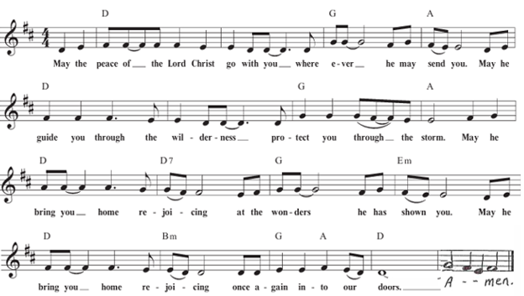

*Postlude
*If you are able to do so, please stand

* * * * * * * * * * * * * * * * * * * * *

Many thanks to Declan Rooney, neighbor of Jeff Allison, for providing this morning’s special music!
Chancel Flowers were given by Dick and Dottie Fleming in memory of loved ones.

Happy Birthday to: Ben Kennedy (07/29) (Please contact the church office if we have missed your birthday or anniversary.)

Happy Anniversary to: There are no anniversaries at this time.

Deacon Greeters/Flower Deliveries: Harriet Rickard and Pat Patterson.

Most Needed Items for SHIM: Dried beans, lentils, pasta sauce in jars, cereal & oatmeal, soup, condiments, spices, adult diapers, baby diapers (size 4-6), dog and cat food, and personal care items.

SHIM Clothing Closet: Accepting donations of clothes (in season), shoes, and linens (no large household items). Located at the Church of Nazarene (5601 Library Road). Drop-off hours: Mondays 10:00 am until 1:00 pm. If you are not able to deliver your donations during their hours, you can leave them in the closet outside of Findley Hall and a Mission Commission member will deliver them for you.

Hospital visits by Pastor Laura can be scheduled through the church office. If you or someone you know is having surgery or is in the hospital, please let us know so that Pastor Laura can be there to visit and pray with you and your loved ones.

Scheduling a Meeting with Pastor Laura: If you would like to meet with Pastor Laura to discuss a matter that is not a medical or pastoral care emergency, please reach out to her. You can contact her via email at revlaurastrauss@gmail.com or by calling the church office at (412) 561-6261 to schedule a meeting. Dropping in to say “hi” is always appreciated, but scheduling a meeting ensures that Pastor Laura can dedicate the necessary time to your discussion if needed.

PRAYER LIST
(Please contact the church office if you would like to add or update a prayer request.)

Prayer Circle: David Petty, Marge Petty and Rosalie Pillitteri.

July: Evelyn Lape (broken foot)

June: Bev Knasko (continued recovery from CDiff), Venerina Deioloius (John Ellis, III's mother-in-law), Family of Joan Greenaway (Linda DeBor’s sister) Ron Sumner (Amy Sumner's husband, cancer), Rev. Elizabeth Wallace (Pastor Laura's friend; breast cancer and sepsis).

Ongoing –Ron Sumner; Nancy Brumfield; our mission co-workers at the U.S.-Mexico border, the Rev. Mark Adams and Miriam Maldonado Escobar and their children, Cindy, Anna Flor, and Nathan; our sister church in Malawi, Africa, Litchenza CCAP; our WorldVision child, Pabatso Makhalanyane; and all those who are affected by natural disasters.

ANNOUNCEMENTS

- Welcome Visitors! If you are worshiping here for the first time today, welcome! We are glad to have you with us.

- Offering: The offering is collected following worship by an elder at the back of the sanctuary who will be holding an offering basket. We can also give online by going to shupchurch.org. Our gifts take many forms: open-hearted presence here, voices lifted in song, the prayers that rise in us, the material gifts we share with neighbors, and our willingness to live in a world as allies and advocates for those whose needs are overlooked. The monies we bring symbolize the offering of our lives in all circumstances.

- Adult Sunday School will be studying Amy-Jill Levine's The Bible With and Without Jesus: How Jews and Christians Read the Same Texts Differently beginning Sunday, June 14. Esteemed Bible scholars and teachers Amy-Jill Levine and Marc Z. Brettler take readers on a guided tour of the most popular Hebrew Bible passages quoted in the New Testament to show what the texts meant in their original contexts and then how Jews and Christians, over time, understood those same texts. Passages include the creation of the world, the role of Adam and Eve, the Suffering Servant of Isaiah, the book of Jonah, and Psalm 22, whose words, “My God, my God, why have you forsaken me,” Jesus quotes as he dies on the cross. Adult Sunday School meets every Sunday at 9:00 a.m.

- Volunteers Needed for VBS! Our VBS this year will be held August 3–7, with the theme of Rainforest Falls. We’re looking forward to having another great group of kids this year, and will need lots of volunteers in various areas. Please let Pastor Laura know if you’re able to help in this important neighborhood outreach!

- Ecumenical Community Gathers to Pray Outside ICE Offices Weekly prayer vigils continue every Friday morning at 8:30 a.m. outside the Immigration & Customs Enforcement (ICE) Office in Pittsburgh's South Side (3000 Sidney St, 15203). Facilitated by a different faith community each week, the vigil is a legal, peaceful witness of support for local immigrants. People of all faith backgrounds are welcome and Presbyterians are always represented well.

- Read the New Testament in ’26: A Bible reading and discussion group is taking place at 6:30 pm, at the home of Jeff Alllison. Call or text Jeff at 412-780-3787 for details and sign-ups.

- Book Club: The July meeting will be held July 29 and we will be discussing Stephanie Dray and Laura Kamoie's novel, America's First Daughter.

- Refugee Youth in need! Do you have space in your heart and home for a Refugee Youth in need? Bethany Christian Services’ Refugee Foster Care Program is currently looking for foster homes for Refugee Youth between the ages of 12-17. The children in the program do not have family reunification possibilities and are in desperate need of long-term, loving placements. The majority of the children are Christian/Catholic youth arriving from Central and South America. The children all have legal status in the United States and a pathway to US Citizenship. If you are interested in learning more, please contact Annelise Halstead at annelisehalstead@bethany.org or visit our website at www.bethany.org/refugeefostercare

- Pet Blessing: All species welcome on a leash or in a carrier. There will be Blessings, food, games and fun for the whole family on August 30th from 6-8pm. We look forward to meeting you and your pet!

- Articles for The Messenger: If you plan on submitting an article for The Messenger, please do so by the 15th of each month.


Welcome to
Sunset Hills
United Presbyterian Church
Phone: 412-561-6261
Office hours: Monday – Thursday, 9:00 am – 3:00 pm
900 Country Club Dr. Pittsburgh, PA 15228
www.shupchurch.org

CHURCH CALENDAR

Sunday, July 26
9:00 am – Adult Sunday School–Findley
9:00 am – Children’s Sunday School
10:15 am – Worship–Sanctuary
10:45 am – Children’s Church–Room 113
2:00 pm – Girl Scouts
6:00 pm – AA

Monday, July 27
9:00 am – Monday Morning Marvels

Tuesday, July 28
7:00 pm – Square Dance Club – Crystal
7:00pm– Counseling Group–Marvel’s Lounge

Wednesday, July 29
10:00 am – Days for Girls
2:00 pm – Parkinson’s Exercise Group
7:30 pm – Book Club

Thursday, July 30
10:00 am – Quilters

Friday, July 31
5:00 pm – AA

Sunday, August 2
9:00 am – Adult Sunday School–Findley
9:00 am – Children’s Sunday School
10:15 am – Worship – Sanctuary
10:45 am – Children’s Church – Rm 113
2:00 pm – Girl Scouts
6:00 pm – AA

