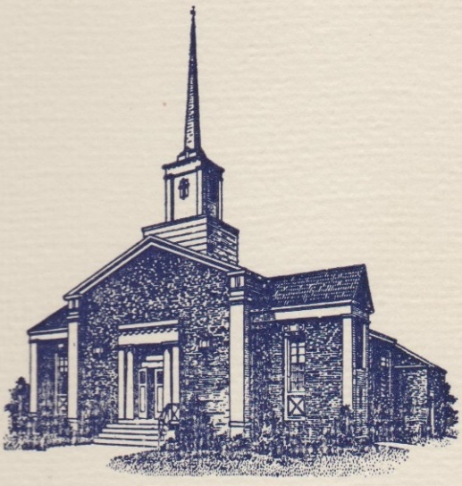
Sunset Hills United
Presbyterian Church
900 Country Club Drive
Pittsburgh, PA 15228
www.shupchurch.org
10:15 am WORSHIP
October 11, 2026
20th Sunday After Pentecost

IN PREPARATION FOR WORSHIP

“The Word, through whom the worlds were made, weeps like a baby at the grave of his friend. Only when we stop and ponder this will we fully understand the full mystery of John’s gospel.”
– N.T. Wright, English Theologian

“In the days of his flesh, Jesus offered up prayers and supplications, with loud cries and tears…”
– Hebrews 5:7

ENTERING GOD’S PRESENCE

Announcements

Lighting of the Christ Candle

Prayer of Preparation

Introit: Surely the Presence of the Lord L. Wolfe
Surely the presence of the Lord is in this place.
I can feel His mighty power and His grace.
I can hear the brush of angels’ wings,
I see glory on each face.
Surely the presence of the Lord is in this place.
CCLI #1065469

Call to Worship: Liturgist: Debbie Edwards

One: Jesus loved Martha and Mary and Lazarus.
All: We worship a God who loves deeply.
One: Jesus stood beside his grieving friends.
All: We worship a God who draws near.
One: Jesus saw their tears and wept with them.
All: We worship a God who is not distant from our sorrow.
One: Come with your joy and your grief, your faith and your doubt.
All: We come as we are to worship the God who meets us here.

Hymn: Blessed Assurance, Jesus Is Mine! No. 341

*Call to Confession:
We sometimes imagine that strong faith means hiding our sorrow or finding the right words for mysteries beyond our understanding. But Jesus did not turn away from grief. He entered it. Trusting the compassion of Christ, let us bring our whole selves before God. Let us confess our need using the prayer of confession.

*Prayer of Confession:
Compassionate God, forgive us when we hurry past sorrow. We offer explanations when someone needs our presence. We search for silver linings when someone needs permission to grieve. We hide our own tears because we fear they make us weak. Forgive us when we have treated grief as a problem to solve instead of a burden to share. Teach us the courage of Christ: to draw near, to pay attention, to love deeply enough to weep, and to trust that neither sorrow nor death has the final word. Amen.

*Assurance of Pardon:
Leader: Jesus wept—and then Jesus called Lazarus from the tomb. This is the good news: the God who shares our tears is also the God who calls us toward life. Nothing we grieve is beyond God's compassion. Nothing we have done is beyond God's grace. Nothing, not even death, can separate us from God's love.
People: In Jesus Christ, we are forgiven and made new. Thanks be to God!

*Response Alleluia!
All creatures, your Creator bless,
And worship God in humbleness.
O sing ye! Alleluia!
Praise, praise the Father, praise the Son,
And praise the Spirit, Three in One!
O sing ye! Alleluia!
Alleluia! Alleluia! Alleluia!
*The Passing of the Peace
Leader: Peace be with you.
People: And also with you.

Anthem: Cornerstone P. Choplin

HEARING GOD’S WORD

Hymn: Jesus Loves Me!

Children’s Story Time

Scripture Readings:

Gospel: John 11:32-44
³² When Mary came where Jesus was and saw him, she knelt at his feet and said to him, ‘Lord, if you had been here, my brother would not have died.’ ³³ When Jesus saw her weeping, and the Jews who came with her also weeping, he was greatly disturbed in spirit and deeply moved. ³⁴ He said, ‘Where have you laid him?’ They said to him, ‘Lord, come and see.’ ³⁵ Jesus began to weep. ³⁶ So the Jews said, ‘See how he loved him!’ ³⁷ But some of them said, ‘Could not he who opened the eyes of the blind man have kept this man from dying?’
³⁸ Then Jesus, again greatly disturbed, came to the tomb. It was a cave, and a stone was lying against it. ³⁹ Jesus said, ‘Take away the stone.’ Martha, the sister of the dead man, said to him, ‘Lord, already there is a stench because he has been dead for four days.’ ⁴⁰ Jesus said to her, ‘Did I not tell you that if you believed, you would see the glory of God?’ ⁴¹ So they took away the stone. And Jesus looked upwards and said, ‘Father, I thank you for having heard me. ⁴² I knew that you always hear me, but I have said this for the sake of the crowd standing here, so that they may believe that you sent me.’ ⁴³ When he had said this, he cried with a loud voice, ‘Lazarus, come out!’ ⁴⁴ The dead man came out, his hands and feet bound with strips of cloth, and his face wrapped in a cloth. Jesus said to them, ‘Unbind him, and let him go.’

Leader: The Word of the Lord!
People: Thanks be to God.

Sermon And Still, Jesus Wept. Rev. Dr. Laura Strauss
Hymn: It Is Well with My Soul Insert
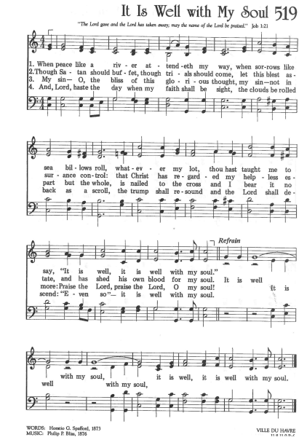
RESPONDING TO GOD’S WORD

Affirmation of Faith: The Heidelberg Catechism, Question 1
One: What is your only comfort, in life and in death?
All: That I belong—body and soul, in life and in death—not to myself but to my faithful Savior, Jesus Christ.

Joys, Concerns, & Testimonies

Prayers of the People & The Lord’s Prayer
Our Father who art in heaven, hallowed be thy name.
Thy kingdom come, thy will be done, on earth as it is in heaven.
Give us this day our daily bread;
and forgive us our debts, as we forgive our debtors;
and lead us not into temptation, but deliver us from evil.
For thine is the kingdom and the power and the glory, forever. Amen.

Presenting Gifts, Tithes and Offerings

Prayer of Dedication

*Response: Doxology
Praise God, from whom all blessings flow;
Praise Him, all creatures here below;
Praise Him above, ye heav’nly host;
Praise Father, Son, and Holy Ghost. Amen.

DEPARTING TO SERVE

Hymn: Take Thou Our Minds, Dear Lord No. 392

Benediction:
May the peace of the Lord Christ go with you; wherever he may send you; may he guide you through the wilderness; protect you through the storm; may he bring you home rejoicing; at the wonders he has shown you; may he bring you home rejoicing; once again into our doors.
Response: God Be With You
God be with you till we meet again,
loving counsels guide, uphold you,
With a Shepherd’s care enfold you;
God be with you till we meet again.

*Postlude
*If you are able to do so, please stand
* * * * * * * * * * * * * * * * * * * * *

Chancel Flowers were given by Debbie Edwards in honor of the SHUP Staff.

Happy Birthday to: Susan Pochek (10/11), Chris Duffner (10/13), Victoria Vernacchio (10/14), Emily Hricko (10/16). (Please contact the church office if we have missed your birthday or anniversary.)

Happy Anniversary to: There are no anniversaries at this time.

Deacon Greeters/Flower Deliveries: Carol Noonan and Debbie Edwards.

Most Needed Items for SHIM: Dried beans, lentils, pasta sauce in jars, cereal & oatmeal, soup, condiments, spices, dog and cat food, and personal care items.

SHIM Clothing Closet: Accepting donations of clothes (in season), shoes, and linens (no large household items). Located at the Church of Nazarene (5601 Library Road). Drop-off hours: Mondays 10:00 am until 1:00 pm. If you are not able to deliver your donations during their hours, you can leave them in the closet outside of Findley Hall and a Mission Commission member will deliver them for you.

Hospital visits by Pastor Laura can be scheduled through the church office. If you or someone you know is having surgery or is in the hospital, please let us know so that Pastor Laura can be there to visit and pray with you and your loved ones.

Scheduling a Meeting with Pastor Laura: If you would like to meet with Pastor Laura to discuss a matter that is not a medical or pastoral care emergency, please reach out to her. You can contact her via email at revlaurastrauss@gmail.com or by calling the church office at (412) 561-6261 to schedule a meeting. Dropping in to say “hi” is always appreciated, but scheduling a meeting ensures that Pastor Laura can dedicate the necessary time to your discussion if needed.

PRAYER LIST
(Please contact the church office if you would like to add or update a prayer request.)

Prayer Circle: Eric Stuart, Ethan Stuart, Kara Stuart

October: Dottie Fleming (Illness), The Family of Bernie Gordon, Family of Conrad Sikirica (Cousin of the Obarsky Family), The Stilley Family (student of Ryan Gracey; sudden passing of mom, April; prayers for husband, Jamie, and kids, Alice and Mallory, and nephew/nieces, Nolan, Mae, and Louis), Becker Family (The passing of John Becker, husband and father) Bayles Family, Mental Health Struggles (Mary Abbott), The Family of Dr. Idris Evans (Died in Home Invasion), Evelyn Lape (On-going Home Repair), Mary Thompson (Dottie Fleming's Sister; Surgery), Family of Barry Luokkala (Friend of Jeff Hinkelman), National Hispanic Heritage Month (Lee Cepits; Prayers of Appreciation)

September: Dorene Hirshika (passing of mom; friend of Darlene Farabaugh), Alecia and Dave Marney (celebration of marriage, Sept. 12, 2026), Linda (car accident, friend of LoAnn Burian), Tom (friend of Rosalie Pillitteri), The Rabbani Family (Granddaughter born with heart problems. Neighbors of the Fako Family.), Evelyn Lape (Damage to her home from the recent storm.), The Brady Family (Damage to their home from the recent storm, Carol Noonan’s neighbor), Lucy Josephine Escobar (new grandchild of Keith and Wendy Yanda, daughter of Michelle (Yanda) and Daniel Escobar), born August 28 in Santa Cruz, CA.

Ongoing – Captain Sam Wright; Ron Sumner; Nancy Brumfield; our mission co-workers at the U.S.-Mexico border, the Rev. Mark Adams and Miriam Maldonado Escobar and their children, Cindy, Anna Flor, and Nathan; our sister church in Malawi, Africa, Litchenza CCAP; our WorldVision child, Pabatso Makhalanyane; and all those who are affected by natural disasters.

ANNOUNCEMENTS

- Welcome Visitors! If you are worshiping here for the first time today, welcome! We are glad to have you with us.

- Offering: The offering is collected following worship by an elder at the back of the sanctuary who will be holding an offering basket. We can also give online by going to shupchurch.org. Our gifts take many forms: open-hearted presence here, voices lifted in song, the prayers that rise in us, the material gifts we share with neighbors, and our willingness to live in a world as allies and advocates for those whose needs are overlooked. The monies we bring symbolize the offering of our lives in all circumstances.

- Pasta for a Purpose: On behalf of the Sunset Hills neighborhood, Please join us for our Pasta for a Purpose Dinner on October 25th at 5:00 pm as we come together to support the Becker family during this difficult time. Your support, generosity, and prayers mean so much to this family as they navigate this season of loss. We hope you’ll join us for a wonderful evening of good food, fellowship, and community support!

- SHUP Flu & COVID Shot Clinic: SHUP’s annual Flu & COVID Shot Clinic will be held on Sunday, October 25, immediately following worship. Immunizations offered will include Flu, Flu HD, COVID, Pneumonia, RSV, and Shingles. If you receive your first Shingles shot at the clinic, you will need to follow up with Pathways for your second dose. Please take advantage of this convenient opportunity to stay up to date on your vaccinations!

- Thanksgiving Dinner: You're invited to join Sunset Hills UP Church for Thanksgiving Dinner on Sunday, November 15 at 5:00 p.m. If your name begins with A-L, bring a side dish. If your name begins with M-Z, bring a dessert. Turkey, stuffing and rolls are provided.
- Ecumenical Community Gathers to Pray Outside ICE Offices Weekly prayer vigils continue every Friday morning at 8:30 a.m. outside the Immigration & Customs Enforcement (ICE) Office in Pittsburgh's South Side (3000 Sidney St, 15203). Facilitated by a different faith community each week, the vigil is a legal, peaceful witness of support for local immigrants. People of all faith backgrounds are welcome and Presbyterians are always represented well.

- Book Club: The September meeting will be held October 28 and we will be discussing A Burning in My Bones: The Authorized Biography of Eugene H. Peterson by Winn Collier.

- Faith and the World: Cookie Chats: You're invited to join Pastor Laura in the church library on the second Sunday of the month at 7:00 p.m. for Cookie Chats. Bring your own beverage and cookies will be provided. The schedule is as follows:
October 11: Death and Dying - Most of us avoid talking about death until we can't. Let's explore what the Christian faith has to say about mortality, grief, and hope. From funeral homes to resurrection hope, how does the Christian story help us face death?
November 8: Christian Nationalism - Can love of country and loyalty to Christ ever come into tension? Let's explore the question together. What happens when religious identity and national identity become difficult to distinguish?
January 10: Loneliness and Belonging - We're living through what some researchers call an epidemic of loneliness. What is loneliness doing to us, and what does the church have that social media, streaming services, and busy schedules cannot provide?

- Articles for The Messenger: If you plan on submitting an article for The Messenger, please do so by the 15th of each month.


Welcome to
Sunset Hills
United Presbyterian Church
Phone: 412-561-6261
Office hours: Monday, Tuesday, Thursday, 9:00 am – 2:00 pm
900 Country Club Dr. Pittsburgh, PA 15228
www.shupchurch.org

CHURCH CALENDAR

Sunday, October 11
9:00 am – Adult Sunday School–Findley
9:00 am – Children’s Sunday School
10:15 am – Worship – Sanctuary
10:45 am – Children’s Church – Rm 113
11:15 am – Nominating Committee Meeting
2:00 pm – Girl Scouts
4:00 pm – Girl Scouts Troop 16212
7:00 pm – Faith and the World: Cookie Chats

Monday, October 12
9:00 am – Monday Marvels
10:00 am – Staff Meeting
1:00 pm – Women’s Bible Study

Tuesday, October 13
12:30 pm – Tuesday Bible Study
6:45 pm – Handbell Choir
7:00 pm – Square Dance Club – Crystal
7:00 pm – Counseling Group–Marvel’s Lounge
7:30 pm – Choir

Wednesday, October 14
10:00 am – Days for Girls
2:00 pm – Parkinson’s Exercise Group
4:00 pm – Quilters
7:30 pm – Session Meeting
Friday, October 16
5:00 pm – AA

Sunday, October 18
9:00 am – Adult Sunday School–Findley
9:00 am – Children’s Sunday School
10:15 am – Worship – Sanctuary
10:45 am – Children’s Church – Rm 113
2:00 pm – Girl Scouts

