
Sunset Hills United
Presbyterian Church
900 Country Club Drive
Pittsburgh, PA 15228
www.shupchurch.org
10:15 am WORSHIP
August 9, 2026
11th Sunday After Pentecost

IN PREPARATION FOR WORSHIP

“Joy does not simply happen to us. We have to choose joy and keep choosing it every day.”
–Henri Nouwen

“We need joy as we need air.”
–Maya Angelou

ENTERING GOD’S PRESENCE

Prelude

Announcements

Lighting of the Christ Candle

Prayer of Preparation

Introit: Sweet, Sweet Spirit B & G Gaither

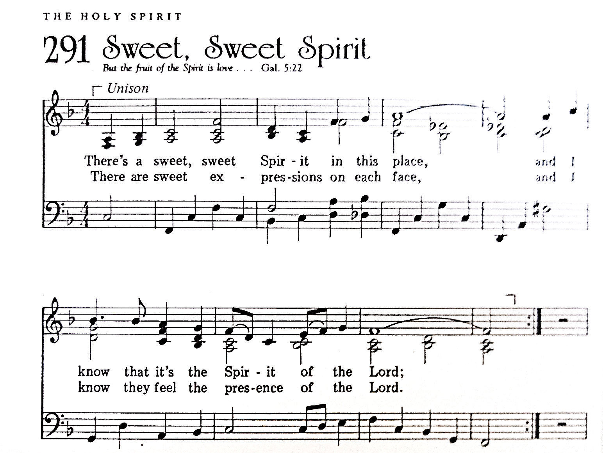
CCLI #1065469

Call to Worship: Liturgist: Dave Petty

Leader: From the smallest drop of rain to the tallest tree in the forest, God’s creation is alive with wonder.
People: We come to worship the God who made it all.
Leader: In rushing rivers and quiet streams, in bright birds and hidden creatures,
People: God’s presence surrounds us.
Leader: Whether we come full of joy or carrying heavy hearts,
People: God meets us here.
Leader: Come, let us worship the Creator, who knows us, loves us, and never lets us go.
People: Let us worship God!

Hymn: Guide Me, O Thou Great Jehovah No. 281

*Call to Confession:
Siblings in Christ, remember that God loves us; therefore by the mercy of God, let us learn to do good. Let us pray together the prayer of confession.

*Prayer of Confession:
God of the forest and the falling rain, you created a world that is connected and full of life. But we confess we do not always live as part of that goodness. We rush past beauty without noticing it. We take more than we need. We forget that we belong to You—and to one another. We try to control what was meant to be received. We lose sight of your care for all creation, including us. Forgive us. Slow us down. Remind us that we are held in your abundant, life-giving love. Amen.

*Assurance of Pardon:
Leader: Friends, hear the good news: The God who created this world and called it good. Therefore, God does not abandon it—and does not abandon you. God’s grace comes to us again and again— refreshing, renewing, restoring. In Jesus Christ, you are forgiven, loved, and made new. Thanks be to God.

People: Thanks be to God! Amen!

*Response Gloria Patri
Glory be to the Father, and to the Son and to the Holy Ghost.
As it was in the beginning, is now and ever shall be.
World without end. Amen. Amen.

*The Passing of the Peace, American Sign Language
Leader: Peace be with you.
People: And also with you.

Bell Duet: Be Thou My Vision arr. T. Doran
(Marla Bruschi & Shelby Gracey)

HEARING GOD’S WORD

Hymn: Jesus Loves Me!

Children’s Story Time Elder Ryan Gracey

Scripture Readings:

Old Testament: Jeremiah 2:5-19
What wrong did your ancestors find in me that they went far from me,and went after worthless things, and became worthless themselves? ⁶ They did not say, ‘Where is the Lord who brought us up from the land of Egypt, who led us in the wilderness, in a land of deserts and pits, in a land of drought and deep darkness, in a land that no one passes through, where no one lives?’⁷ I brought you into a plentiful land to eat its fruits and its good things. But when you entered you defiled my land, and made my heritage an abomination.⁸ The priests did not say, ‘Where is the Lord?’ Those who handle the law did not know me; the rulers^{[a]} transgressed against me; the prophets prophesied by Baal, and went after things that do not profit. ⁹ Therefore once more I accuse you, says the Lord, and I accuse your children’s children. ¹⁰ Cross to the coasts of Cyprus and look, send to Kedar and examine with care; see if there has ever been such a thing. ¹¹ Has a nation changed its gods, even though they are no gods? But my people have changed their glory for something that does not profit. ¹² Be appalled, O heavens, at this, be shocked, be utterly desolate, says the Lord, ¹³ for my people have committed two evils: they have forsaken me, the fountain of living water, and dug out cisterns for themselves, cracked cisterns that can hold no water. ¹⁴ Is Israel a slave? Is he a home-born servant? Why then has he become plunder? ¹⁵ The lions have roared against him, they have roared loudly. They have made his land a waste; his cities are in ruins, without inhabitant. ¹⁶ Moreover, the people of Memphis and Tahpanhes have broken the crown of your head. ¹⁷ Have you not brought this upon yourself by forsaking the Lord your God, while he led you in the way? ¹⁸ What then do you gain by going to Egypt, to drink the waters of the Nile? Or what do you gain by going to Assyria, to drink the waters of the Euphrates? ¹⁹ Your wickedness will punish you, and your apostasies will convict you. Know and see that it is evil and bitter for you to forsake the Lord your God; the fear of me is not in you, says the Lord God of hosts.

New Testament: Philippians 4:4-13
Final Exhortations
⁴ Rejoice in the Lord always. I will say it again: Rejoice! ⁵ Let your gentleness be evident to all. The Lord is near. ⁶ Do not be anxious about anything, but in every situation, by prayer and petition, with thanksgiving, present your requests to God. ⁷ And the peace of God, which transcends all understanding, will guard your hearts and your minds in Christ Jesus.
⁸ Finally, brothers and sisters, whatever is true, whatever is noble, whatever is right, whatever is pure, whatever is lovely, whatever is admirable—if anything is excellent or praiseworthy—think about such things. ⁹ Whatever you have learned or received or heard from me, or seen in me—put it into practice. And the God of peace will be with you.
Thanks for Their Gifts
¹⁰ I rejoiced greatly in the Lord that at last you renewed your concern for me. Indeed, you were concerned, but you had no opportunity to show it. ¹¹ I am not saying this because I am in need, for I have learned to be content whatever the circumstances. ¹² I know what it is to be in need, and I know what it is to have plenty. I have learned the secret of being content in any and every situation, whether well fed or hungry, whether living in plenty or in want. ¹³ I can do all this through him who gives me strength.

Leader: The Word of the Lord!
People: Thanks be to God.

Sermon Rev. Ralph Lowe

Hymn: O Jesus, I Have Promised No. 388

RESPONDING TO GOD’S WORD

Affirmation of Faith: A Brief Statement of Faith
We trust in God the Holy Spirit, everywhere the giver and renewer of life. The Spirit justifies us by grace through faith, sets us free to accept ourselves and to love God and neighbor, and binds us together with all believers in the one body of Christ, the Church. The same Spirit who inspired the prophets and apostles rules our faith and life in Christ through Scripture, engages us through the Word proclaimed, claims us in the waters of baptism, feeds us with the bread of life and the cup of salvation, and calls women and men to all ministries of the Church. In a broken and fearful world the Spirit gives us courage to pray without ceasing, to witness among all peoples to Christ as Lord and Savior, to unmask idolatries in Church and culture, to hear the voices of peoples long silenced, and to work with others for justice, freedom, and peace. In gratitude to God, empowered by the Spirit, we strive to serve Christ in our daily tasks and to live holy and joyful lives. Amen.

Joys, Concerns, & Testimonies

Prayers of the People

Presenting Gifts, Tithes and Offerings

Prayer of Dedication

*Response: Doxology
Praise God, from whom all blessings flow;
Praise Him, all creatures here below;
Praise Him above, ye heav’nly host;
Praise Father, Son, and Holy Ghost. Amen.

DEPARTING TO SERVE

Hymn: Blest Be the Tie That Binds No. 438

Benediction:
May the peace of the Lord Christ go with you; wherever he may send you; may he guide you through the wilderness; protect you through the storm; may he bring you home rejoicing; at the wonders he has shown you; may he bring you home rejoicing; once again into our doors.
Response: Spiritual Amen No. 587

*Postlude
*If you are able to do so, please stand

* * * * * * * * * * * * * * * * * * * * *

Many thanks to Marla Bruschi for her special music this morning in the bell duet!

Chancel Flowers were given by Rev. Dr. William and Shelby Gracey in honor of their children and granddaughters.

Happy Birthday to: Dottie Flemming (08/10), Kailey Hepburn (08/10), Sarajane Obarsky (08/13), Judy Stacey (08/13), Rowan Zeglin (08/14), Robert Tang (08/15). (Please contact the church office if we have missed your birthday or anniversary.)

Happy Anniversary to: William and Barbara Geary (08/10), David and Michelle Brumfield (08/12).

Deacon Greeters/Flower Deliveries: Carol Noonan and Pat Patterson.

Most Needed Items for SHIM: Dried beans, lentils, pasta sauce in jars, cereal & oatmeal, soup, condiments, spices, adult diapers, baby diapers (size 4-6), dog and cat food, and personal care items.

SHIM Clothing Closet: Accepting donations of clothes (in season), shoes, and linens (no large household items). Located at the Church of Nazarene (5601 Library Road). Drop-off hours: Mondays 10:00 am until 1:00 pm. If you are not able to deliver your donations during their hours, you can leave them in the closet outside of Findley Hall and a Mission Commission member will deliver them for you.

Hospital visits by Pastor Laura can be scheduled through the church office. If you or someone you know is having surgery or is in the hospital, please let us know so that Pastor Laura can be there to visit and pray with you and your loved ones.

Scheduling a Meeting with Pastor Laura: If you would like to meet with Pastor Laura to discuss a matter that is not a medical or pastoral care emergency, please reach out to her. You can contact her via email at revlaurastrauss@gmail.com or by calling the church office at (412) 561-6261 to schedule a meeting. Dropping in to say “hi” is always appreciated, but scheduling a meeting ensures that Pastor Laura can dedicate the necessary time to your discussion if needed.

PRAYER LIST
(Please contact the church office if you would like to add or update a prayer request.)

Prayer Circle: Susan Pochek, Harriet Rickard and Amy Riley.

August: The Van Haitsma family (death of their daughter), Rev. Brenda Barnes (colleague of Pastor Laura; car accident), Tim Fako (prayers for joy in retirement).

July: Evelyn Lape (broken foot)

Ongoing – Captain Sam Wright; Ron Sumner; Nancy Brumfield; our mission co-workers at the U.S.-Mexico border, the Rev. Mark Adams and Miriam Maldonado Escobar and their children, Cindy, Anna Flor, and Nathan; our sister church in Malawi, Africa, Litchenza CCAP; our WorldVision child, Pabatso Makhalanyane; and all those who are affected by natural disasters.

ANNOUNCEMENTS

- Welcome Visitors! If you are worshiping here for the first time today, welcome! We are glad to have you with us.

- Offering: The offering is collected following worship by an elder at the back of the sanctuary who will be holding an offering basket. We can also give online by going to shupchurch.org. Our gifts take many forms: open-hearted presence here, voices lifted in song, the prayers that rise in us, the material gifts we share with neighbors, and our willingness to live in a world as allies and advocates for those whose needs are overlooked. The monies we bring symbolize the offering of our lives in all circumstances.

- Adult Sunday School will be studying Amy-Jill Levine's The Bible With and Without Jesus: How Jews and Christians Read the Same Texts Differently beginning Sunday, June 14. Esteemed Bible scholars and teachers Amy-Jill Levine and Marc Z. Brettler take readers on a guided tour of the most popular Hebrew Bible passages quoted in the New Testament to show what the texts meant in their original contexts and then how Jews and Christians, over time, understood those same texts. Passages include the creation of the world, the role of Adam and Eve, the Suffering Servant of Isaiah, the book of Jonah, and Psalm 22, whose words, “My God, my God, why have you forsaken me,” Jesus quotes as he dies on the cross. Adult Sunday School meets every Sunday at 9:00 a.m.

- Meet Ralph Lowe: Ralph is the primary presbytery staff liaison for the North Branch and West Branch of the Pittsburgh Presbytery, as well as the Administrative Commission for Transformation, Amos 5:24 Ministry Team, Anti-Racism Transformation Team, Freedom Rising Pilot Project, Peacemaking Ministry Team, Hunger Fund Ministry Team, National Black Presbyterian Caucus Pittsburgh Chapter, Great Commission, Matthew 25 On the Move Ministry Team, and the Self-Development of People Ministry Team.

- Ecumenical Community Gathers to Pray Outside ICE Offices Weekly prayer vigils continue every Friday morning at 8:30 a.m. outside the Immigration & Customs Enforcement (ICE) Office in Pittsburgh's South Side (3000 Sidney St, 15203). Facilitated by a different faith community each week, the vigil is a legal, peaceful witness of support for local immigrants. People of all faith backgrounds are welcome and Presbyterians are always represented well.

- Read the New Testament in ’26: A Bible reading and discussion group is taking place at 6:30 pm, at the home of Jeff Alllison. Call or text Jeff at 412-780-3787 for details and sign-ups.

- Book Club: The August meeting will be held August 26 and we will be discussing Aziz Abu Sarah and Maoz Inon’s nonfiction memoir, The Future Is Peace.

- Refugee Youth in need! Do you have space in your heart and home for a Refugee Youth in need? Bethany Christian Services’ Refugee Foster Care Program is currently looking for foster homes for Refugee Youth between the ages of 12-17. The children in the program do not have family reunification possibilities and are in desperate need of long-term, loving placements. The majority of the children are Christian/Catholic youth arriving from Central and South America. The children all have legal status in the United States and a pathway to US Citizenship. If you are interested in learning more, please contact Annelise Halstead at annelisehalstead@bethany.org or visit our website at www.bethany.org/refugeefostercare

- Pet Blessing: All species welcome on a leash or in a carrier. There will be Blessings, food, games and fun for the whole family on August 30th from 6-8pm. We look forward to meeting you and your pet!

- Summer SHUP Diaper Drive for SHIM: Every little one deserves dry and clean diapers, but many families cannot afford them. You can help! Donate diapers and wipes for SHIM's service toward local families in need. Size 4, 5, and 6 are most needed, and pull-ups are always helpful. We will be collecting through August 30 and diapers can be dropped off in the Pack N Play in the Narthex. Together, we can keep little ones happy and healthy. Thank you for your generosity!

- Holy Curiosity Sermon Series: The Bible is full of passages that make us laugh, scratch our heads, argue, wonder, and occasionally say, "Wait - that's in there?" This October and November, Pastor Laura's turning to you. What Scripture have you never heard preached but wish you had? What story deserves another chance? What text has puzzled or inspired you? Drop your suggestions in the wicker basket in the Narthex. Pastor Laura will use these suggestions, and they do not need to have a name on them. Together we'll explore some of the Bible's most surprising corners and discover what treasures await us there.

- Faith and the World: Cookie Chats: You're invited to join Pastor Laura in the church library on the second Sunday of the month at 7:00 p.m. for Cookie Chats. Bring your own beverage and cookies will be provided. The schedule is as follows:
September 13: Artificial Intelligence - AI is changing the way we work, learn, and relate. What wisdom does the Christian faith offer in this new era?
October 11: Death and Dying - Most of us avoid talking about death until we can't. Let's explore what the Christian faith has to say about mortality, grief, and hope. From funeral homes to resurrection hope, how does the Christian story help us face death?
November 8: Christian Nationalism - Can love of country and loyalty to Christ ever come into tension? Let's explore the question together. What happens when religious identity and national identity become difficult to distinguish?
January 10: Loneliness and Belonging - We're living through what some researchers call an epidemic of loneliness. What is loneliness doing to us, and what does the church have that social media, streaming services, and busy schedules cannot provide?

- Articles for The Messenger: If you plan on submitting an article for The Messenger, please do so by the 15th of each month.


Welcome to
Sunset Hills
United Presbyterian Church
Phone: 412-561-6261
Office hours: Monday, Tuesday, Thursday, 9:00 am – 2:00 pm
900 Country Club Dr. Pittsburgh, PA 15228
www.shupchurch.org

CHURCH CALENDAR

Sunday, August 9
9:00 am – Adult Sunday School–Findley
9:00 am – Children’s Sunday School
10:15 am – Worship–Sanctuary
10:45 am – Children’s Church–Room 113
2:00 pm – Girl Scouts

Monday, August 10
9:00 am – Monday Morning Marvels

Tuesday, August 11
7:00 pm – Square Dance Club – Crystal
7:00 pm– Counseling Group–Marvel’s Lounge

Wednesday, August 12
10:00 am – Days for Girls
2:00 pm – Parkinson’s Exercise Group

Thursday, August 13
10:00 am – Quilters

Friday, August 14
5:00 pm – AA

Sunday, August 16
9:00 am – Adult Sunday School–Findley
9:00 am – Children’s Sunday School
10:15 am – Worship – Sanctuary
10:45 am – Children’s Church – Rm 113
2:00 pm – Girl Scout

